Table of Contents
1. Document Outline………..……………….………….……..…….…………..…….…....1
2. Getting Started With AFC…...…………..………….....……….………………....….....2
2.1. Controls
3. Migrating Character To Game/Project….……...……...……………..……….……….3
3.1. Presets System & Default Values
4. Retargeting Animations To AFC…………………………………….….………...…….4
4.1. Loading Presets Inside UE4 Level
5. Procedural Characters………………………………………….…………..…..………..5
5.1. Color Presets
6. Screenshot For Preset……………………………………………………………………6
6.1. Lighting
6.2. Performance
2.Getting Started With AFC
If you are new to AFC Please Read The Q&A to get more familiar with the system
So after getting through the Q&A, you understand this system is made for devs to Generate Female Based Characters with high quality results this system could be used to make variety types of faces / bodies / clothes / textures and so on, you can check my Youtube Channel Here To see how the system works and other tutorials if you have any question or wondering about anything that’s not covered by Q&A or This document feel free to contact me directly on discord Here, with these out of the way let’s start with Controls
2.1. Controls
To navigate through AFC use this default controls Layout For PC
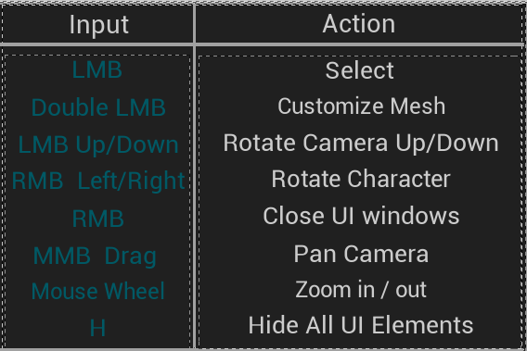
LMB = Left Mouse Button - Double Clicking Cloth UI Will Open Cloth Customization Menu
RMB = Right Mouse Button - Right Clicking And letting go Will Close UI Menu
MMB = Middle Mouse Button
Note: using the system For Vr Or Consoles Read Q&A Number 11/12
3.Migrating Character to Game/Project
AFC made Migrating easy everything is handled on the CharacterCustomization so you just need to make a character preset then get the character Info to your own blueprint and apply it
Here is an example on how it works running on ALS V3
However there is new version of ALS V4 so the video tutorial is in the work for migrating the character with ALS V4 or any other project
3.1.Presets System & Default Values
AFC have up to 30 Save Slots and you can add as much as you want
The save system stores all the data And Default Values under Blueprints/Save_Data
So if you want to change character default clothing Textures Morphing ..etc you can define it Under Save_Data Blueprint and it will be set as Default Value On Project or Game Start, AFC Saves All the data as you choose them so if you close the project or have a crash don’t worry everything is there you don’t have to click confirm button to apply the save
In Project : You can find save files under AFC/Saved/SaveGames/(YourPresetName)
In ShippingBuild : You can locate it under C:\Users\(YourUser)\AppData\Local\AFC\Saved\SaveGames
You can send presets and receive from others devs if you send the preset files under save location
4.Retargeting Animation to AFC
You can follow this tutorial Here if you want to get your animations retargeted from Mannequin
Alternatively you can follow this tutorial Here if you want to retarget animations from Mixamo
Okay Your character is from (Daz,MakeHuman,CC3 ..etc) how do i get animations from them to AFC, you can set them to mannequin pose and set AFC to mannequin pose and do the retargeting there is ton of tutorials out there covering how to get into mannequin pose for all the 3rd party softwares
4.1.Loading Presets Inside a Level (New Update this is not needed anymore use the Migrate node)
In order to load you presets inside a level you need to drag the CharacterCustomization_BP into the level and follow with the gif below
In Here i Put the name of the preset i wanted to load you can put anything else you want i also removed the AddUI so the UI doesn’t get in the way
5.Procedural Characters
Randomly generated characters is a feature in AFC that’s still Work in progress currently you can check it out by going on CharacterCustomization_BP Under event-graph go to Character Randomization Graph and connect The Input Node With Shuffle Node Now by starting the project and Pressing R it will randomize the character however since this feature still Experimental it doesn’t save the end results to the save slot and has few bugs expect the feature to be fully working in the future here is how it looks in its current state
5.1.Color Presets
You can access color presets under UMG/Customization_UMGs there open the UMG you want to change Presets On and open SetPresetColors function there you can change the default colors for any given UMG
6.Screenshot For Presets
AFC Allows users to take screenshots for their gaven Preset by click the Camera icon on top right corner, However screenshots only work in Editor and not in Game Builds this is due to limitation in Blueprints code i couldn’t add CPP code to fix that since this pack is made only In Blueprints so in order to take proper screenshots like the ones included with the pack you need to do it in editor
Note: if you are taking screenshot in Standalone window inside the editor make sure you are not on the main window in ue4 go inside a blueprint or widget otherwise there is a bug in ue4 which will prevent the picture from being taken
6.1.Lighting
If you take the character in a different map or put it in your level you will notice the lighting doesn’t look as good as the one in AFC Character_Showcase level this is because in the Character_Showcase Level uses studio lighting while your level probably doesn’t, you can copy the light from the Showcase level using CTRL+C and paste it in your level Using Ctrl+V,you can also copy the PP (post process) the same way to get the color corrections applied there
Note: if you have a problem with light where topology looks squarey a bit you can lower the shadow bais to fix this problem this happen because the mesh is lowpoly and the lighting is high quality
6.2.Performance
Included with the pack two female models Cinematic & Production the name says it all if you want the best performance use production version if you want the best Quality go with Cinematic Version basically they are low & high poly versions of the model
Other than that you can apply LOD to the character models turn off HeightFog and you will have very Stable & Good performance, if you still have problems running

