OwnIcon V.4

Instructions for using
OwnIcon for V.4
In Version 4, the handling has changed and a few new features have been added.
- EXPLANATION OF THE BUTTONS ETC.
1.1. White Icon
1.2. Reset
1.3. Object Types
1.4. Selected Mesh (ComboBox, Next Item, Anim Position Slider)
1.5. Transform (Loc. X,Y,Z; Rot. X,Y,Z; Save, Center, Mesh Size)
1.6. Resolution
1.7. Mouse Symbol with marked MouseWheel
1.8. Icon Name Textbox
1.9. Create Button
1.10. Orange/Blue Progress Bar
1.11. Lighting (Light 1-4)
1.12. Frame (CheckBox, ComboBox, Stretch, Position, Up/Down, Left/Right)
1.13. Background (CheckBox, RGB Slider, Spin Box)
- START OF ICON CREATION
2.1. Preparation of the objects from which icons are to be created
2.2. Open the user interface
2.3. Choose the resolution
- MESH SELECTION
3.1 Choose the Object Type
3.2. Select the Mesh/Actor
3.3. Animation Settings for Skeletal Mesh/Actor
- LOCATION/ROTATION/SCALE SETTINGS
4.1. Work with Save-System
4.2. Center the Object
4.3. Set the Location, Rotation and Scale
- LIGHTING SETTINGS
5.1 Set the Lighting

- FRAME SETTINGS
6.1. Choose the Frame Style(Image)
6.2. Stretch the Frame
6.3. Change Position of the Frame

- BACKGROUND SETTINGS
7.1. Change the Color of the Background

- CREATE THE ICON
8.1. “Create” or “Create All”

- IMPORTANT AND FINAL STEP
9.1. Find the created Icons
9.2. Edit Icons and Save

- OTHER TUTORIALS
10.1. How to add your own Border
10.2. …. more will follow...

EXPLANATION OF THE BUTTONS ETC.

1.1. White Icon
White Icon ensures that a white icon is generated for the object.
Do not use White Icon in combination with a Backgound.

1.2. Reset
"Reset" resets Location, Rotation and Scale to the initial value.

1.3. Object Types
Determine here what type of mesh is behind the lens. If the object from which you want to create an icon is a Skeletal Mesh, then select Skeletal Mesh here, and so on …
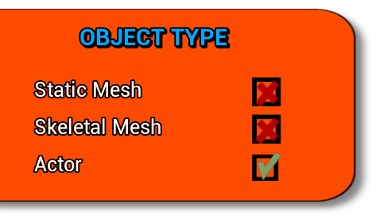

1.4. Selected Mesh (ComboBox, Next Item, Anim Position Slider)
As soon as you have selected what type of mesh it is, the dropdown menu will be loaded with all the corresponding "Items" in the world.
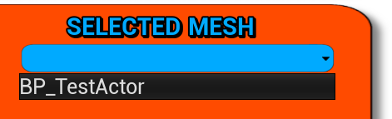
Use the "Next Item" button to click your way through the drop-down list.
If you have chosen the Object Type "Skeletal Mesh" or "Actor", an Anim Position Slider will also appear. With this slider you can select the desired pose of an animation (provided you have assigned an animation to the mesh. More on that later ...)
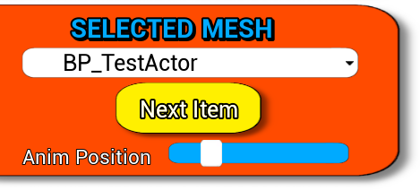

1.5. Transform (Loc. X,Y,Z; Rot. X,Y,Z; Save, Center, Mesh Size)
With the six fields labeled accordingly, you can change the position and rotation of the object.
With the slider "Mesh Size" you can also set the size of the object.
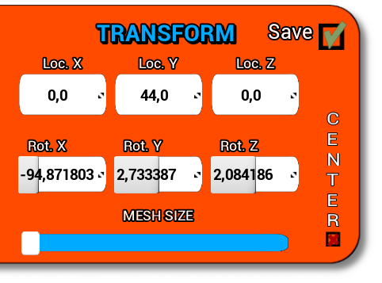
With the "Center" checkbox, the system tries to move the object to the center of the icon.
The "Save" check box activates the save system. This means that each object is saved with its own location, rotation and scale. If the check box is active, it will be saved automatically. The values ​​are always loaded when another object is selected in the drop-down list.

1.6. Resolution
Here you can select the resolution that the icon should have.

1.7. Mouse Symbol with marked MouseWheel
The mouse symbol appears whenever an entry can be changed with the mouse wheel.
If you move the mouse pointer over, for example, the input field for Loc. X, so you can precisely set the location on the X-axis with the mouse wheel.

1.8. Icon Name Textbox
As you can imagine, here is the name that is used when creating the icon.

1.9. Create Button
If you click on this button, the currently displayed icon will be created.

1.10. Orange/Blue Progress Bar
This bar is a progress bar.
This fills up when you create several icons with one click with the "Create all" button.
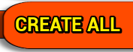

1.11. Lighting (Light 1-4)
Use these sliders to set the lighting of the object and thus the brightness of the icon.
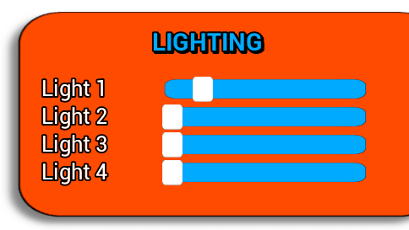

1.12. Frame (CheckBox, ComboBox, Stretch, Position, Up/Down, Left/Right)
Here you will find the settings for the frame of your icon.
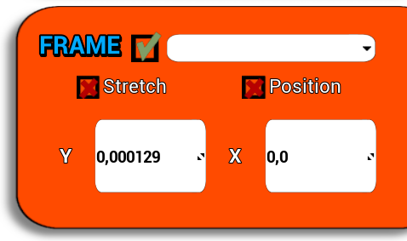
When the check box is activated, there are several setting options for the frame.
If you want to stretch or compress the frame, then check "Stretch" and change the values in Y/X.
If you want to change the position of the frame, then tick "Position" and change the values in Y/X. The values can be entered here again using the left mouse click, the keyboard input or simply using the mouse wheel.

1.13. Background (CheckBox, RGB Slider, Spin Box)
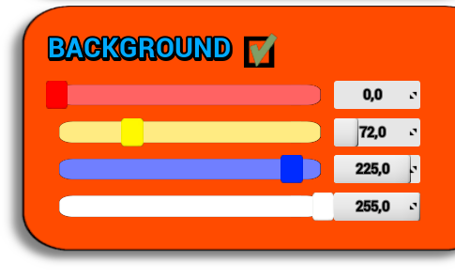
If you want a colored background, you can set it here. Activate the "Background" check box and use the sliders (RGB) to set the color as you wish. Alternatively, you can also enter the values in the input box.

START OF ICON CREATION

2.1. Preparation of the objects from which icons are to be created
First you have to load the "IconMap" level. You can find the level in the folder -> IconCreator-> Map-> IconMap (Level)
Choose the Static Meshes, Skeletal Meshes or Actors and drag them into the world.
For static meshes, you don't have to do anything else to prepare.
With skeletal meshes you have to assign the animation to the skeletal mesh if you want to have a special pose of the item (for example "idle pose" of a character).

If you want to make an icon of an actor, then click on the actor that is already placed in the world and give the actor the tag "Icon".

2.2. Open the user interface
Now click on Play and start the editor.
I recommend starting the editor in a new window and maximizing this window.
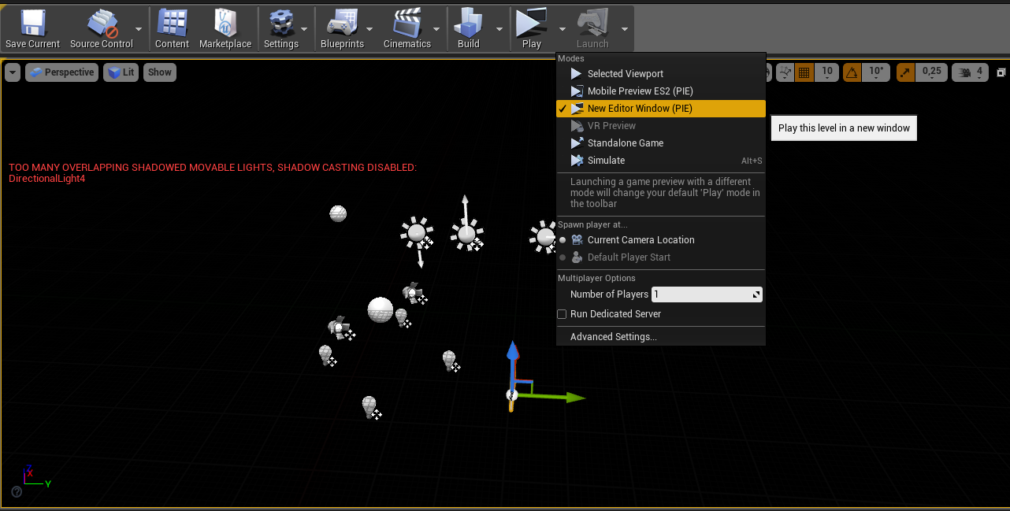

2.3. Choose the resolution
Select the resolution you want the icon to have at the end.

MESH SELECTION

3.1. Choose the Object Type
Select the object type from which you want to create an icon.

3.2. Select the Mesh/Actor
Now you can select one of the meshes you want to start with from the drop-down list.
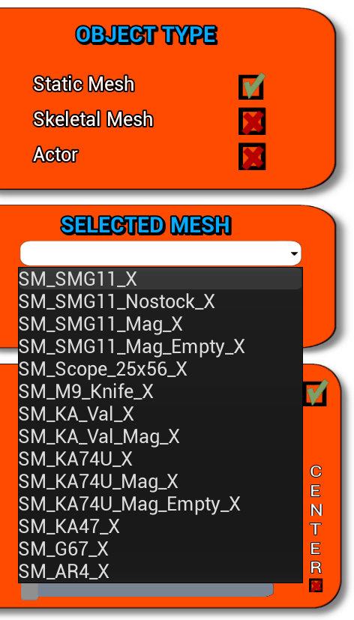

3.3. Animation Settings for Skeletal Mesh/Actor
If you select Skeletal Mesh or Actor and have previously assigned an animation, you can now use the animation slider to set the desired pose.

LOCATION/ROTATION/SCALE SETTINGS

4.1. Work with Save-System
First a few words about the save system:
If you activate the "Save" checkbox, the location, rotation and scale will be loaded whenever you select a new "Item" in the DropBox. Accordingly, an "item" that you have not yet edited is loaded with the default values ​​(0/0/0 ...).
For example, if you want to create several icons in a row where the same values ​​should be used for all icons, deactivate "Save".
You also have the option to copy the values ​​to another:
-> 1. Activate "Save" -> 2. Set all values ​​as you want -> 3. Deactivate "Save" -> 4. Select the next "Item" -> 5. Activate "Save" again. ..

4.2. Center the Object
Choose "Center" to keep the "Item" in the middle of the icon as much as possible. If "Center" is active, you can change the rotation whereby the system keeps the "Root" point of the "Item" in the middle.

4.3. Set the Location, Rotation and Scale
Now change the location and rotation of the "item" using the various input boxes. In addition, you can change the mesh / actor size with the scale slider.
Personally, I think it's best to use the mouse wheel to change the values. If you hover over a box with the mouse pointer, a mouse symbol appears to the left of the Resolution DropBox, which indicates that the mouse wheel can be used for input.

LIGHTING SETTINGS

5.1. Set the Lighting
Use the sliders to adjust the lighting.
There are 4 directional lights on the map that point in a different direction.

FRAME SETTINGS

6.1. Choose the Frame Style(Image)
If you activate the "Frame" checkbox, further settings for the frame appear.
First choose which frame should be displayed. This is done using the drop-down list.S
- Below you will find instructions on how to add your own images, if necessary the tutorial video of the older version. -

6.2. Stretch the Frame
If the "Stretch" checkbox is active, you can use the input fields to change the size in Y and X, which causes the frame to be stretched or compressed. Necessary for a portrait / landscape format.

6.3. Change Position of the Frame
If the "Position" checkbox is active, you can use the values ​​to change the position.
Here I recommend using the mouse wheel again …

BACKGROUND SETTINGS

7.1. Change the Color of the Background
If you activate the "Background" checkbox, sliders appear for setting the color.
Use the slider or enter fixed values ​​in the input box to change red, yellow, blue (RGB).
The alpha slider is currently not working properly and can always be set to "255".

CREATE THE ICON

8.1. “Create” or “Create All”
With the button "Create" you create the icon as you see it in front of you (exception: "White Icon")
If you want to create several icons in a row and these "items" have already been adapted or have similar values ​​from the start (a row of machine guns / a row of pants / a row of food or whatever ...) then you can Click on "Create All" to automatically to create all items of the selected object type (Static Mesh for example) .... -> the progress bar fills up and shows when all items are "Finished".

IMPORTANT AND FINAL STEP

9.1. Find the created Icons
Find the icons you created. You can find these in the folder “BP_and_Textures”.

9.2. Edit Icons and Save
Select all the Icons you have just created and click on them with the “right mouse button”.
Now select “Assets Actions” -> “Bulk Edit via Propterty Matrix …”

In order to use the just made settings of the icons, put a tick on “Compress Without Alpha” and take it out again.
The last step is very important. Click on “File” in the top left corner and then “Save all”.

OTHER TUTORIALS (To be continued…)

