Character Skills

Documentation

(Unreal Engine 4 asset)
https://www.unrealengine.com/marketplace/character-interaction

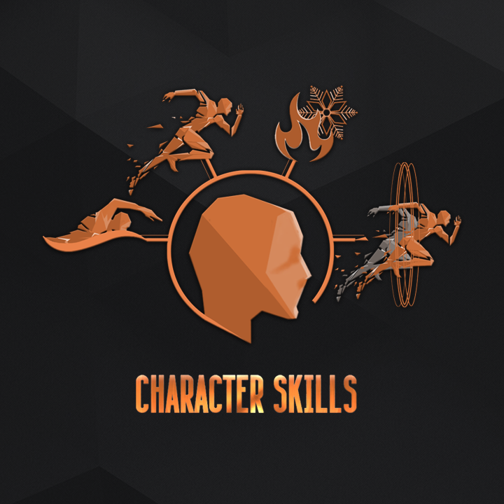
Video overview of the project

Documentation written by the project author ZzGERTzZ.

Manual version : 1.0

Introduction:

The project ‘Character Skills’ was made for the implementation of various skills for the character. Apart from the basic skills, the project also contains a constructor. It is possible to create skills of various complexity with the constructor. There is much content in the asset itself: animation clips, character models, sounds, enemies, effects… We designed the system "Character Skills" in such a way that it will be possible to add it to already existing characters and, thus, broaden the gameplay.

Project integration:

First off, let's discuss the way ‘Character Skills’ works. The main component is “BP_CharacterSkills”: it contains all the logic for the application of skills.So you add this component to the pawn. The component works together with the “AnimBp_CS” animation blueprint (AnimBP) that contains the animated component of the skills. This animBP is added to the animation blueprint of the character. Also, for each skill, there is a class of effects (uobject). Such a class allows one to add any extra logic to the skill. Read more about it in section 'Class of Effects'.
Working principle scheme:
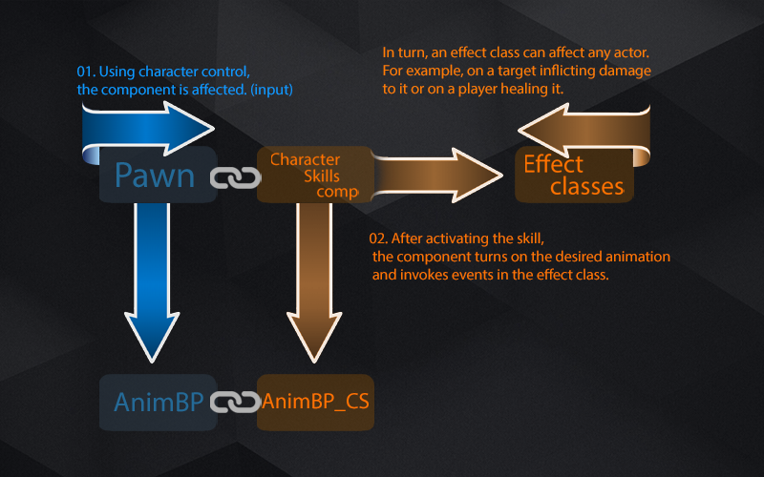
These are the steps one needs to follow to integrate it into an existing project::
Video tutorial on how to add the project based on the standard third-person character
- And the whole content of the project 'Character Skills' into your project with the help of the 'migrate' tool.
- Make sure all the animations are bound to the common skeleton. If you use the basic skeleton provided by epic games (UE4Mannequin) then simply delete the skeleton that is used in 'Character Skills' (CharacterSkills\Character\UE4Mannequin\Mesh\UE4_Mannequin_Skeleton). Select your skeleton as a replacement and press the “Replace References” button when you delete the default one.
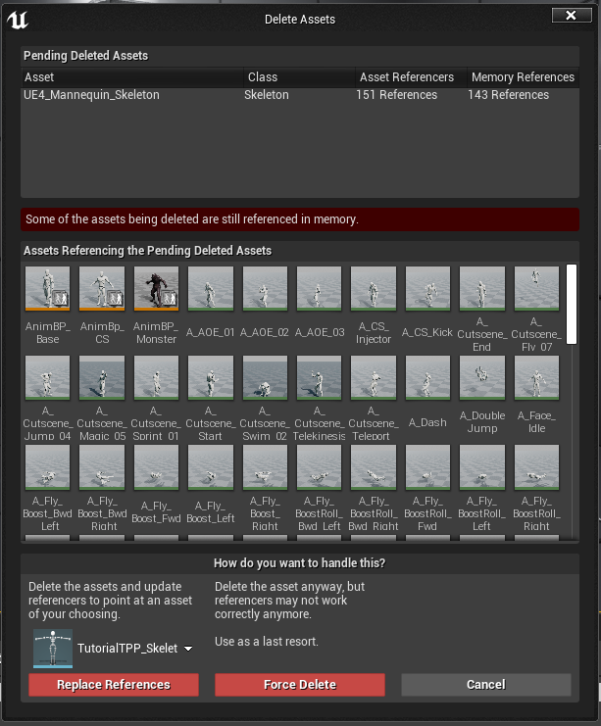
After that, all the skill animations will use this skeleton that you chose when you deleted the other one. You need to retarget animBP “AnimBP_CS” if you don't use the UE4 skeleton.
If you must open “AnimBP_CS” and make sure it is functioning correctly after you replace the original skeleton.
- Now how to add the “BP_CharacterSkills” component to the pawn. Open your pawn and with the help of the button 'add component' add “BP_CharacterSkills” to it. You may rename it as you wish while doing so but if you copy the code from the example pawn then name it 'CharacterSkills'.
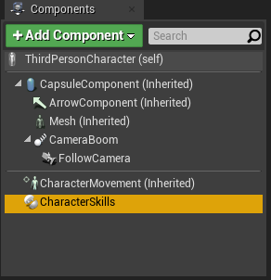
- Then you must specify an animBP for your character. For that, first, remove the animBP shown in the character's mesh and choose it in the component ''Character Skills'' in tab 'Character animeBP'. Here is an example of how it should look like in the end for you: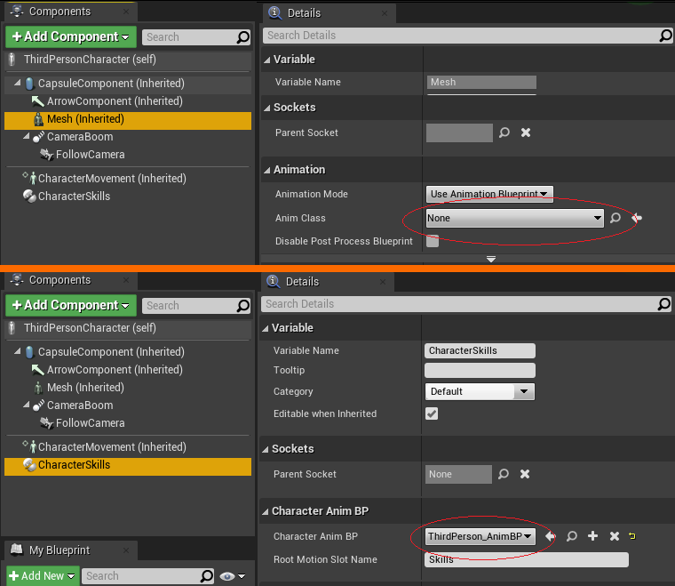
- If the previous steps are successful, then the system 'Character Skills' is added successfully as well. What's left is to add necessary nodes for skills to work and to control the skills. The first thing is to add the node “CharacterMovementSkill” to where you update character’s movements. The node determines whether to use the movements from the skill component (if you’ve activated skills for relocation like swimming or flying...) or to continue using regular movements of your character. Add one node for the forward vector and one for the right one. Here is an example of how it should turn out when using the standard third-person template: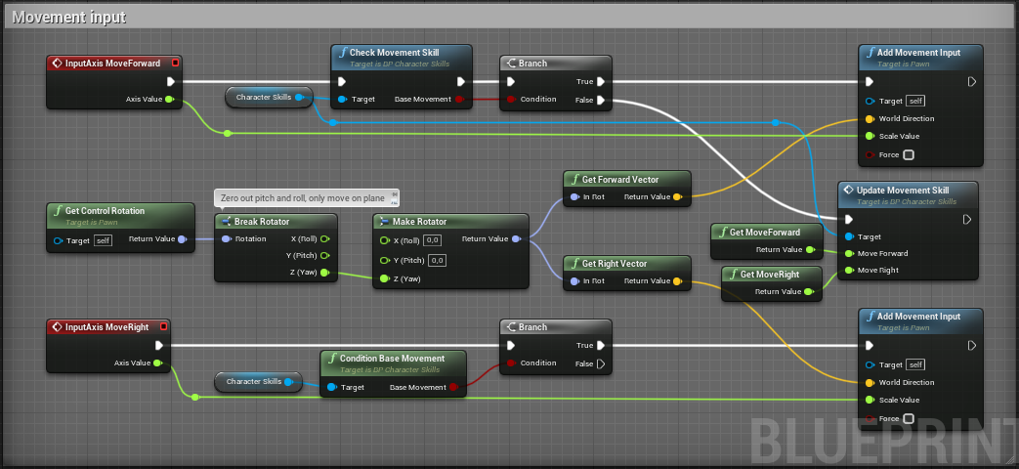
Further, if you want to use the skill 'telekinesis' in your project, then you should add nodes to the view inputs.
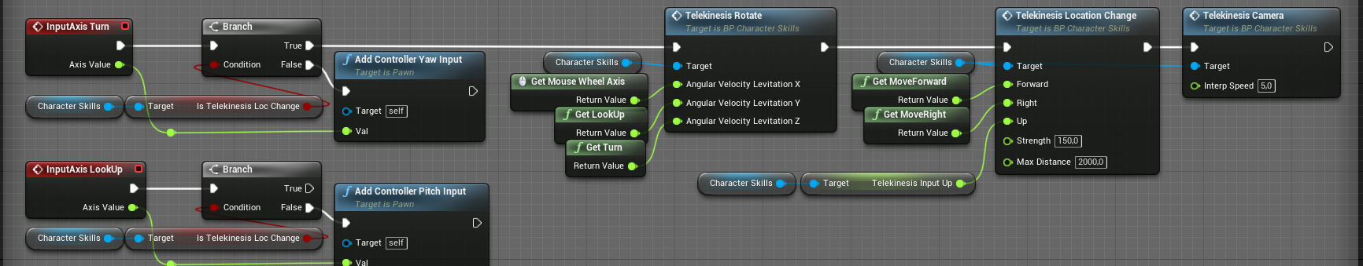
These nodes determine whether you move the object with the help of the 'telekinesis' or not. If you do, then inputs are directed into the component 'Character Skills' with the help of which you move the object.
The next step is to add inputs for moving downwards. You need them if you want to use the skills of flying or swimming: the character will move down when flying or dive when swimming upon pressing this button. Also, it’s worth including lowering the object for the ‘telekinesis’. You may set up any control scheme. By default, the left control is used.
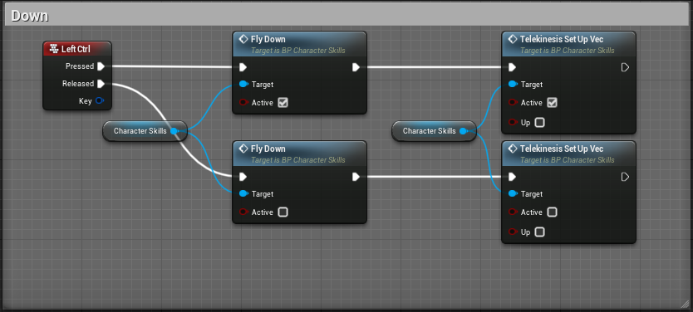
Further, we need to add direction upwards. Here we consider the case when one button should take into account several actions. In the example, ‘space’ is used for jumping, for gaining height, for double jumping, for lifting an object with the help of the telekinesis.
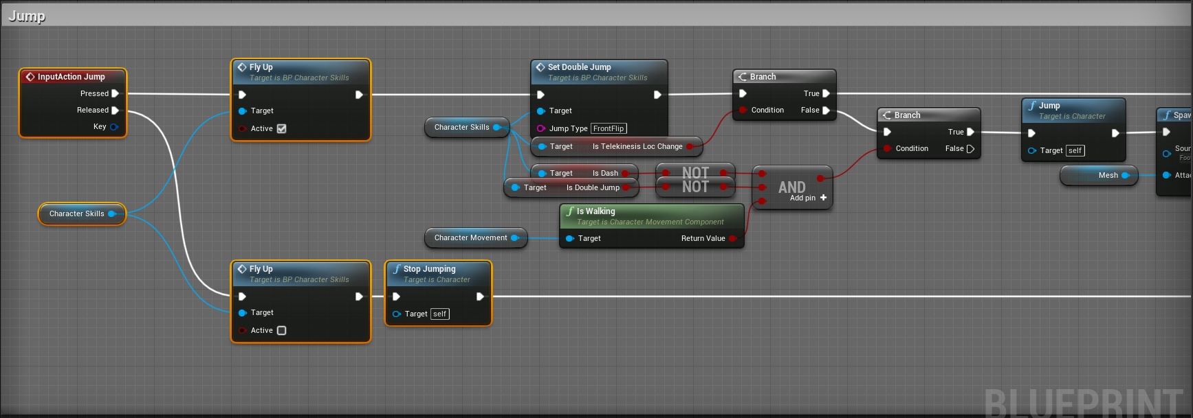
The first thing is to add upward direction (vector) nodes for flying and swimming (FlyUp): it is activated upon pressing the button and it is deactivated upon the release of the button.

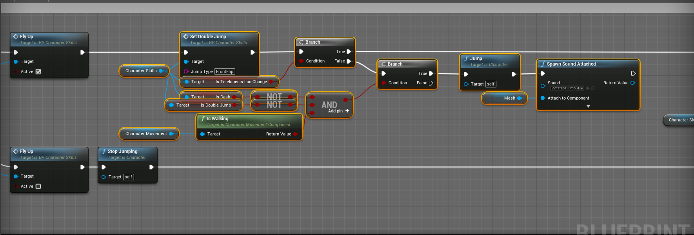
The next step is to add the node for the double jump “SetDoubleJump”. In this function, the component will calculate by itself whether the character is able to double jump in a particular moment based on the settings or not. There's no need to specify extra conditions. Further, we check whether we are moving an object with the help of the telekinesis or not. If we do, skip the activation of the jump and turn on the function for lifting the object. If we don't use the telekinesis, then we check whether the character is not in the state of the double jump or he isn’t dashing or standing on the ground. The jumping is executed if all the conditions are met.
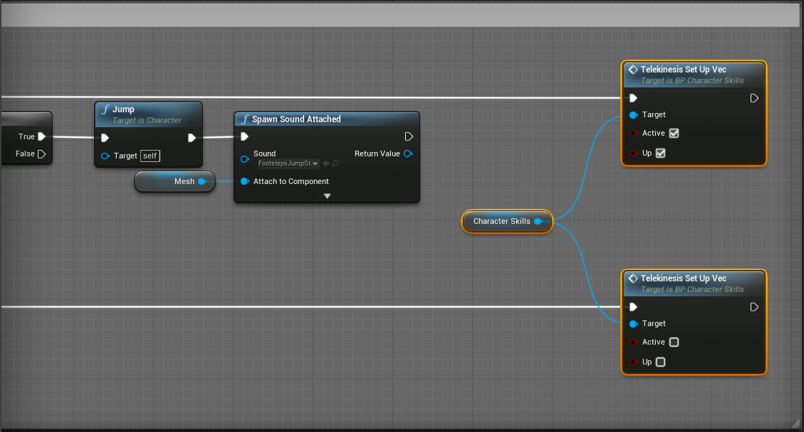

These are nodes for the upward vector of the telekinesis. With the help of such conditions, one can use a single button for various actions based on the states of the character.

At this stage, the integration of the component 'Character Skills' is completed. Next, we consider skills and how to add them to the project.

Skills:

There are several basic skills and there is the constructor of skills in the project. First of all, we consider basic skills. All the settings of skills are in component ‘Character Skills’ in tab Settings. To access them, select the component and find data in tab “Details”. Many skills have parameters of mana and stamina. They are two scales that can be used in skills. When there is insufficient mana or stamina then the skill can’t be activated. It is not mandatory to use the parameters.
Sprinting skill:

Sprint is a skill that allows the character to run fast.
Use the node “SetSprint” to activate it:
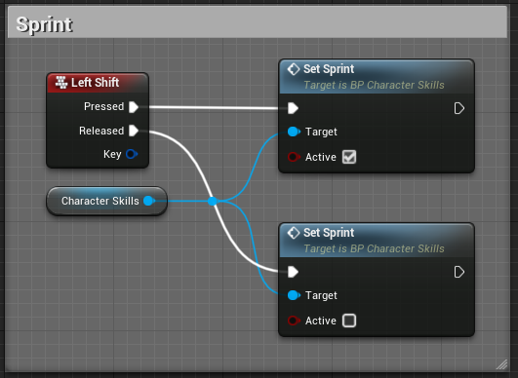
In the current example, the sprint is activated or deactivated upon pressing or releasing the left shift respectively.

Settings of the 'Sprint' skill:
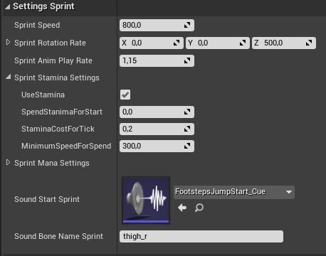
Sprint Speed is the running speed during the sprint.
Sprint Rotation Rate - is the turning rate of the character during the sprint.
Sprint Anim Play Rate - is the animation playback multiplier.
Sprint Stamina Settings - is stamina usage settings.
Sprint Mana Settings - is mana usage settings.
Sound Start Sprint - is the sound for the beginning of the sprint.
Sound Bone Name Sprint - is a bone of the skeleton from which the sound will be emitted.

Additional functions and variables when using the skill:
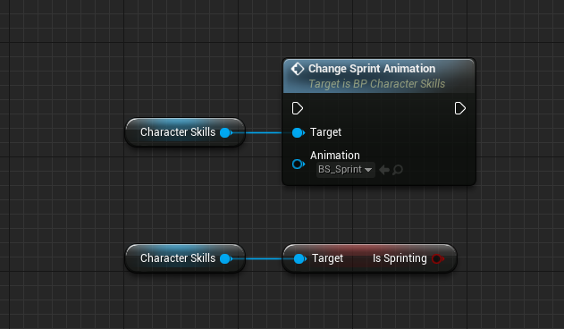
Change Sprint Animation - is used to replace the sprinting skill animations.
IsSprinting - is a Boolean variable identifying the sprinting state.

Swimming skill:

The swimming skill contains settings for character behavior in water. The character behavior borrows some settings from the character movement from Epic Games. In the first place, set up the parameters in the character movement component.
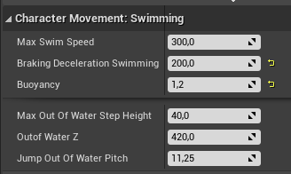
After that, place a Physics Volume in the level with the 'Water Volume' parameter enabled. It is the volume that will serve as water for the character.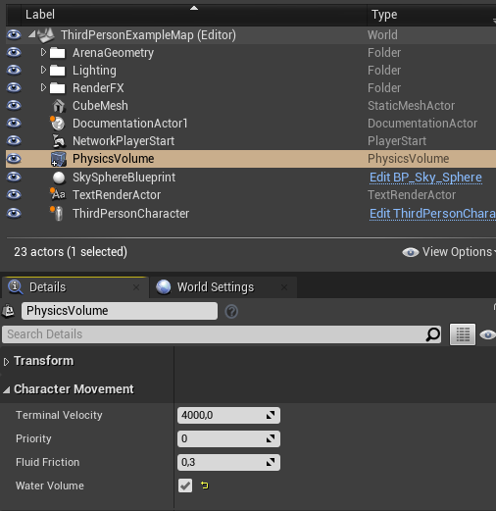
Settings of the 'Swim' skill:
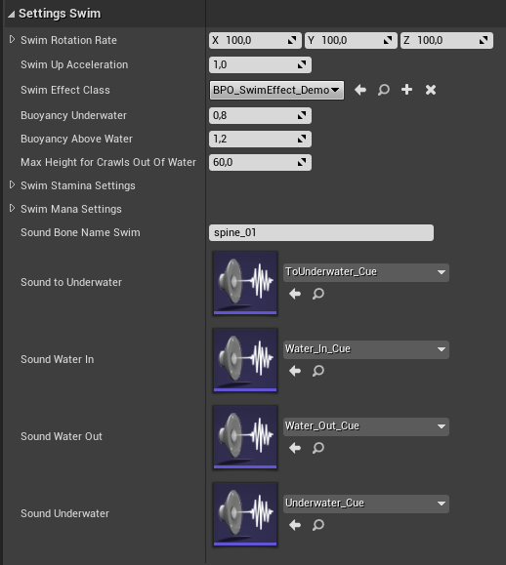
Swim Rotation Rate - is the character's turning rate in water.
Swim Up Acceleration - is the rate at which the vertical speed is being gained, i.e. the vertical acceleration.
Swim Effect Class - is the effect class for the swimming skill.
Buoyancy Underwater - is the buoyancy force underwater.
Buoyancy Above Water - is the buoyancy force above the water surface.
Max Height for Crawls Out of Water - is the height of a ledge that the character can reach when he's climbing out of the water.
Swim Stamina Settings - are stamina usage settings.
Swim Mana Settings - are mana usage settings.
Sound Bone Name Swim - is a bone of the skeleton from which the sounds will be emitted.
Next come settings of sounds when transitioning states during swimming

Additional functions and variables when using the skill:
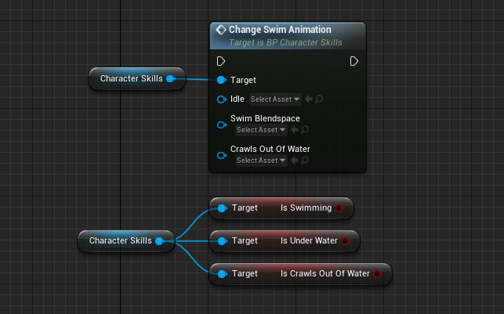

Change Swim Animation - is a function for replacing the swimming animations. If there's a need to replace certain animations then leave the rest with the empty reference so they won't be replaced.
IsSwimming - is a Boolean variable identifying the swimming state.
IsUnderWater - If True, then the character is underwater. It is False when he/she is on the water surface.
IsCrawlsOutOfWater - is a Boolean variable identifying the state of getting out of the water.
Events in the class of effects (refer to section "Class of Effects" for details)
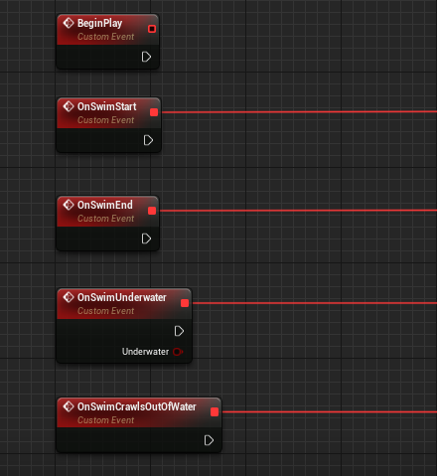

BeginPlay - It is triggered right after the initialization of the component 'Character Skills'. It is used to add various content, for instance, water particles that will be turned on or turned off depending on the condition.
OnSwimStart - It is triggered right after the character gets into the water.
OnSwimEnd - It is triggered right after the character leaves the water.
OnSwimUnderwater - It is triggered when changing the state underwater and on the water surface. It is set by the parameter ‘Underwater’.
OnSwimCrawlsOutOfWater - It is triggered right after the character begins climbing out of the water by reaching a ledge.

Flying skill:

The flying skill allows the characters to travel above the ground. The skill comprises two flying modes:
- Hovering just like a helicopter when the character can cruise along local axes relative to the eye direction.
- Flying like an airplane when the character moves in the direction of the view.
By default, the first mode is used as the main one, and the second one is used during an accelerated flight. Also, by default, the ‘boostroll’ is enabled that adds a little bit of extra speed to the character and it can be activated only during the second flying mode.

The following functions are required for integrating the skill:

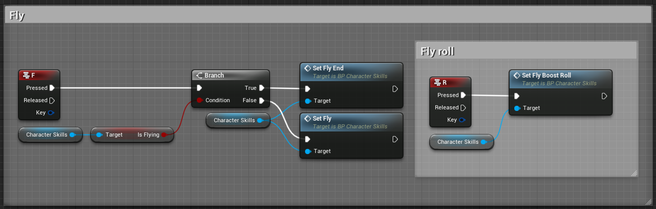

SetFly - sets the character into the flight state.
SetFlyEnd - leaves the flight state.
SetFlyBoostRoll - launches the boostroll.

In the basic example (see figure below), the logic checks whether the character is in the flight state upon pressing the ‘F’ button. If False, then the character lifts off. Otherwise, it leaves the flight state.
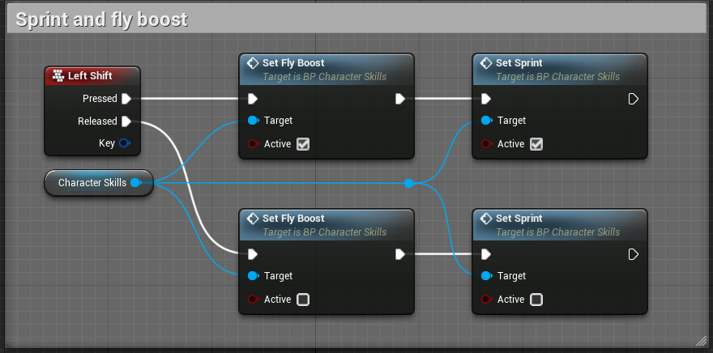
SetFlyBoost - transitions into the accelerated flight mode of the second type. By default, it is done with the Left Shift button.

Next come the functions for the upward and downward directions SetFlyUp and SetFlyDown respectively that we’ve discussed in section “Project integration” already. These functions are needed for upwards and downwards movements relative to the character and they are used during the first flying mode. Let’s move to the skill settings.
Settings of the 'Fly' skill:
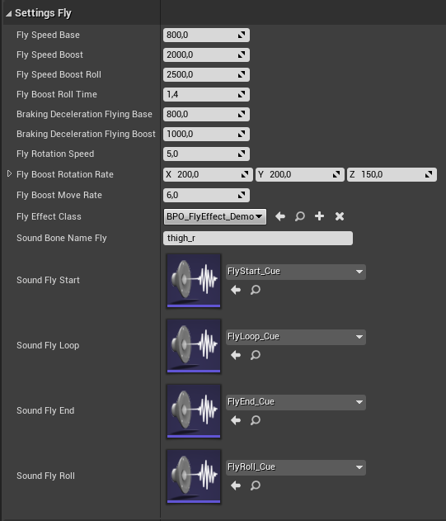
FlySpeedBase - is the flight speed of the first flight mode.
FlySpeedBoost - is the flight speed of the second flight mode.
FlySpeedBoostRoll - is the speed of doing the ‘boostroll’ maneuver.
FlyBoostRollTime - is the duration of the ‘boostroll’.
BrakingDecelerationFlyingBase - is the air resistance during the first mode of flying.
BrakingDecelerationFlyingBoost - is the air resistance during the second mode of flying.
FlyRotationSpeed - is the rotation rate of the character in the first flight mode.
FlyBoostRotationRate - is the rotation rate of the character in the second flight mode.
FlyBoostMoveRate - is the rotation rate of the character during the ‘boostroll’.
FlyEffectClass - is the class of effects for the flying skill.
SoundBoneNameFly - is a bone of the character's skeleton to which the sound is attached.
Next come the sounds of the various flight states.
Additional functions and variables when using the skill:
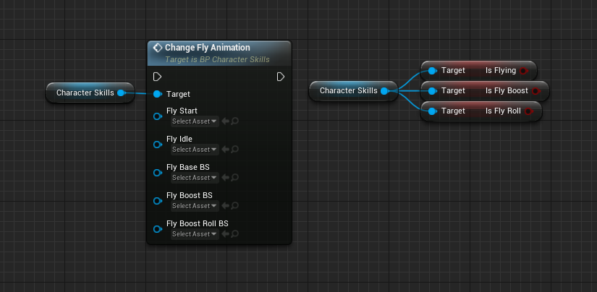
Change Fly Animation - is a function for replacement of flying animations. If there's a need to replace certain animations, then leave the rest with the empty reference so they won't be replaced.
IsFlying - is a Boolean variable identifying the flying state.
IsFlyBoost - is a Boolean variable identifying the flying state of the second mode.
IsFlyRoll - is a Boolean variable identifying the ‘boostroll’ state.

Events in the class of effects (refer to section "Class of Effects" for details)
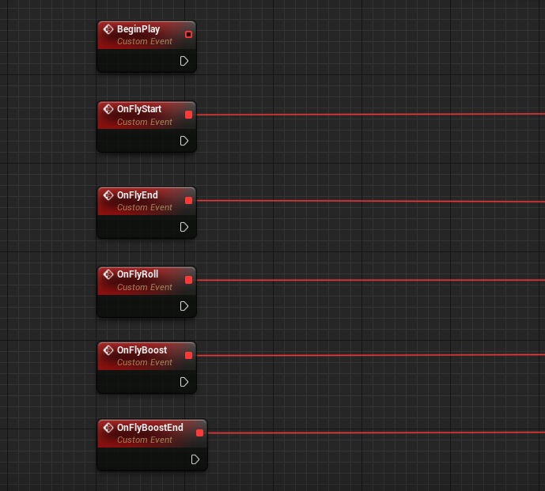
BeginPlay - It is triggered right after the initialization of the components 'Character skills'. It is useful for adding various content, for instance, flight particles that will be turned on or turned off depending on the condition.
OnFlyStart - It is triggered right after the character lifts off the ground.
OnFlyEnd - It is triggered right after the character exits the flight state.
OnFlyRoll - It is triggered when executing the ‘boostroll’.
OnFlyBoost - It is triggered as soon as the character transitions into the second flight mode.
OnFlyBoostEnd - It is triggered when the character exits the flight mode of the second kind.
Super Jump skill:

The super jump skill allows the character to leap at longer distances. To execute the super jump, the character must prepare for it. The super jump is implemented with the help of the following functions:

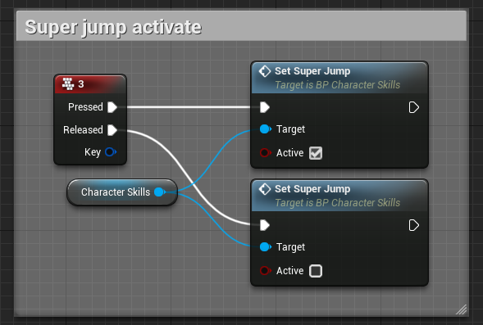
By default, upon pressing button 3, the character gets in a prep position.Upon the release of the button, if the character has managed to prepare for the jump, he will do it. If the character did manage to prepare for the jump, he would return in the basic state. The jump is being done in the direction of the movement prior to it.
Settings of the “SuperJump” skill:
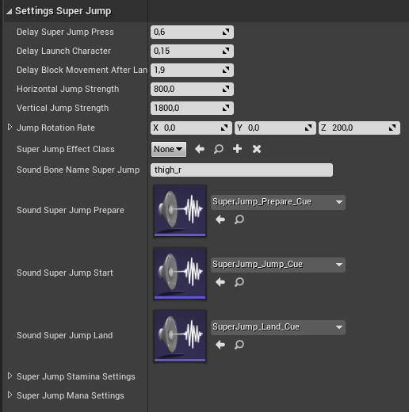
DelaySuperJumpPress - is the time necessary for the character to prepare for the jump.
DelayLaunchCharacter - is a time delay before the execution of the super jump.
DelayBlockMovementAfterLand - is the amount of time the character movement will be blocked after landing.
Horizontal JumpStrength - is the horizontal force of the jump.
VerticalJumpStrength - is the vertical force of the jump.
JumpRotationRate - is the rotation rate of the character in the air during the super jump.
SuperJumpEffectClass - is the class of effects for the super jump skill.
SoundBoneNameSuperJump - is a bone of the character’s skeleton to which the sounds of the skill will be attached.
Next come the settings of sounds and usage of mana and stamina.

Additional functions and variables when using the skill:
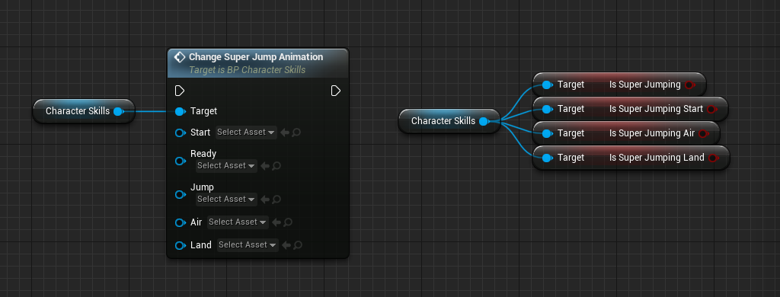
ChangeSuperJumpAnimation - is a function for the replacement of super jump animations. If there's a need to replace certain animations, then leave the rest with the empty reference so they won't be replaced.
IsSuperJumping - is a Boolean variable identifying the state of the super jump being applied in the current moment.
IsSuperJumpingStart - is a Boolean variable identifying the state of the start of the super jump.
IsSuperJumpingAir - is a Boolean variable identifying the state of the super jump in the air.
IsSuperJumpingLand - is a Boolean variable identifying the state of landing after the super jump.

Events in the class of effects (refer to section "Class of Effects" for details)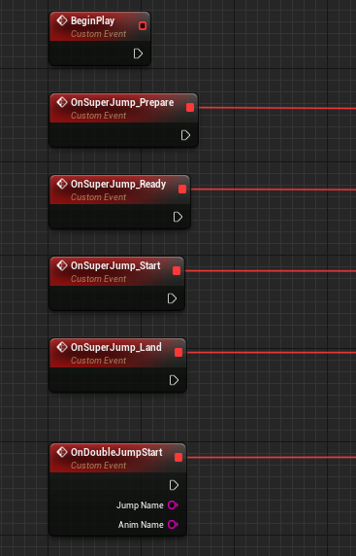
OnSuperJump_Prepare - is triggered when preparing for the jump.
OnSuperJump_Ready - is triggered as soon as the character is ready to execute the jump.
OnSuperJump_Start - is triggered during the moment of the jump activation.
OnSuperJump_Land - is triggered at the moment of landing after the super jump.
OnDoubleJumpStart - is triggered during the double jump.

Double jump skill:
The double jump skill allows the character to do extra jumps in the air. The following function is used to activate the skill:
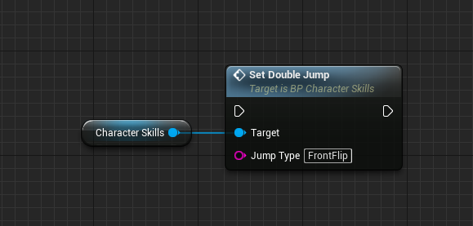
By default, SetDoubleJump is triggered upon pressing the jump button (Space). The jump type is specified in the parameter JumpType . It is possible to create any number of jumps with different parameters. Let's consider the settings of the “DoubleJump” skill.
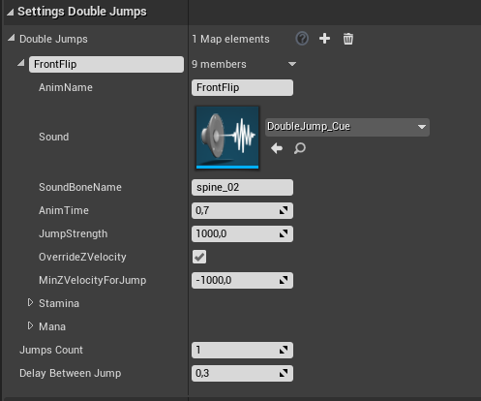
DoubleJumps - is a map variable in which the parameters for the jumps are created. It is possible to make any number of jumps and simply provide the name of a jump needed to be activated in the call function. By default, one jump type was added called “FrontFlip”.
AnimName - is a name of the jump animation. The animation itself is specified in “AnimBP_CS” in tab “Animations Double Jump” and is assigned the name (map variable).
Sound - is a sound when doing this jump.
SoundBoneName - is the name of the character's skeleton bone from which the sound will be emitted.
AnimTime - is the animation duration of the jump.
JumpStength - is the jumping force.
OverrideZVelocity - When the parameter is enabled, the jumping force will overwrite the current speed of the character along the z-axis (the vertical axis). When disabled, the speed will be added to the current speed of the character.
MinZVelocityForJump - is the minimum speed of the character along the vertical axis needed to do the current jump. It's a useful parameter when, for instance, you want to exclude the possibility of the second jump when the character falls down.
Stamina - is the stamina usage cost when jumping.
Mana - is the mana usage cost during the jump.
JumpCount - is a number of possible jumps before the character lands. It can be useful when one is planning to make a series of jumps in the air.
DelayBetweenJump - is a time-delay between jumps if there are several of them.

Additional functions and variables when using the skill:
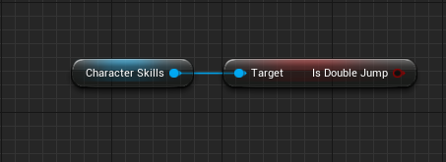

IsDoubleJump - is a Boolean variable identifying the state of active double jump skill.

Events in the class of effects (refer to section "Class of Effects" for details). Note that the class of effects was merged with the super jump skill (it is specified in tab “Settings Super Jump”) and it has a single event.

OnDoubleJumpStart - is triggered just when the super double jump starts. JumpName - is the name of the jump type, AnimName - is the name of the animation.

Dash skill:
This skill allows the character to dodge by moving to sides. In this skill, it is possible to use both the root-bone animation and adjust the shift with the help of a curve. The skill is triggered with the help of the function “SetDash” that is bound to the V button by default.
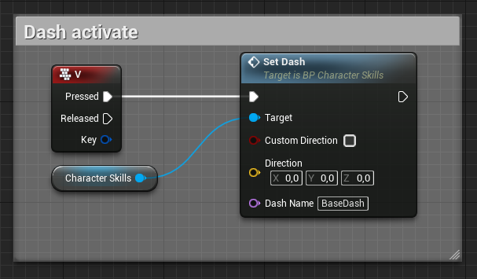
CustomDirection - By default, the direction is set in the direction specified by the player during his movements. You need to turn this parameter on if it's necessary to set a specific direction.
Direction - The field must be specified if the above option is enabled.
DashName - The name of the dash (set in settings).

Settings of the “Dash” skill:
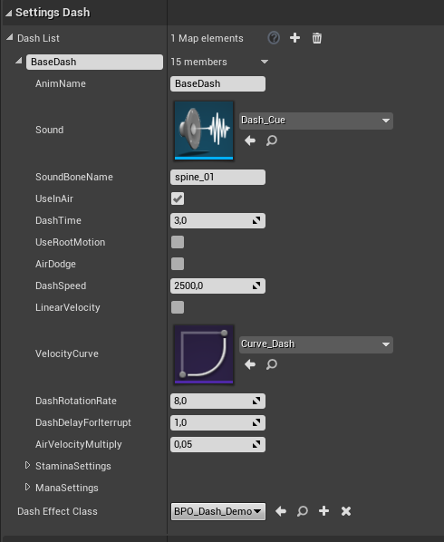
DashList - is a list of possible dashing movements. Each dashing movement should get a name and settings assigned to it. The name is used to call the dashing movement in the function “SetDash”.
AnimName - is the name of the dash animation. The animation itself is specified in “AnimBP_CS” in tab “Animations Dash” and is assigned the name (map variable).
Sound - is a dashing sound..
SoundBoneName - is the name of the character's skeleton bone to which the sound will be attached.
UseInAir - Whether it is possible to use the dashing movement in the air.
DashTime - is the duration of the dash.
UseRootMotion - Whether to use the root-bone animation. If yes, then the speed parameter can be skipped.
AirDodge - Whether the character will fall in the air when applying this dash. It can work with the root animation as well. It's a useful parameter when it's needed to maintain the characters's height during dashing.
DashSpeed - is the maximum dashing speed.
LinearVelocity - Whether the character will move linearly or with a variation of speed.
VelocityCurve - It is necessary to set up the curve if the parameter for linear motion is disabled. The curve sets how the character will change his velocity during the dash.
DashRotationRate - is the turning rate of the character relative to the direction of the dash.
DashDelayForInterrupt - is a time delay after which it is possible to interrupt the dash.
AirVelocityMultiply - is the speed multiplier during the dash in the air.
StaminaSettings - are stamina usage settings when dashing.
ManaSettings - are mana usage settings when dashing.
DashEffectClass - is the class of effects for dashing.

Additional functions and variables when using the skill:
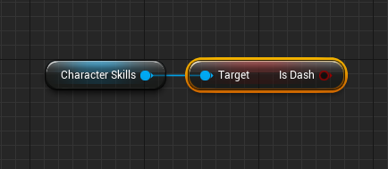
IsDash - is a Boolean variable identifying the state of active dashing skill.
Events in the class of effects (refer to section "Class of Effects" for details).
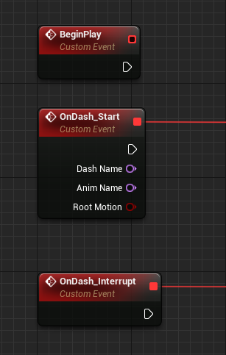
OnDash_Start - is called when the dash is activated. DashName is the name of the dash, AnimName is the name for its animation, RootMotion determines whether the animation of the current dash is of the “RootMotion” type.
OnDash_Intterupt - is called when the skill is interrupted.

Teleportation Skill:
The teleportation skill allows the character to instantly travel over certain distances.By default, one chooses the spot for the teleportation with the help of viewing controls. After that, after saving the spot location, it is possible to teleport the character there at any time. Teleportation is called with the help of the following functions:
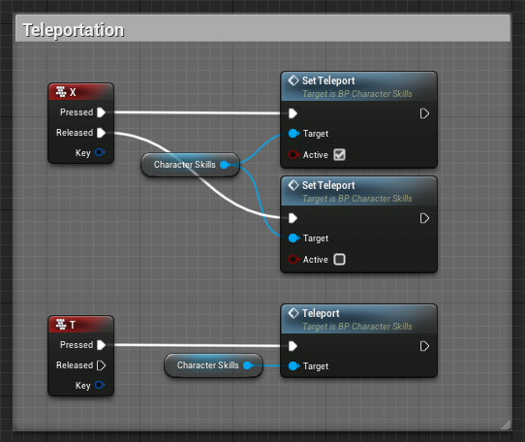
SetTeleport - is a function to determine the teleportation spot location.
Teleport - is a function that is responsible for the start of the teleportation.

Teleportation skills settings:
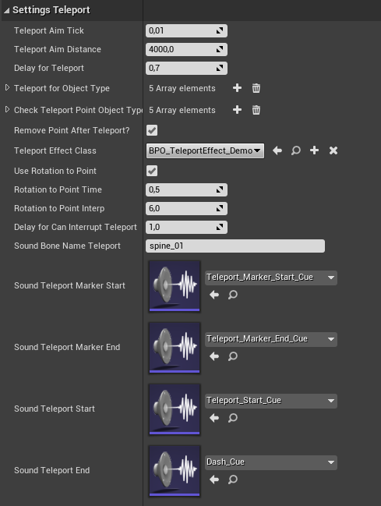
TeleportAimTick - is a parameter that specifies how often the crosshair for picking a spot for the teleportation will be updated.
TeleportAimDistance - is the maximum distance the character can teleport over.
DelayForTeleport - is a time delay before the teleportation after it is called. For instance, for the animation playback.
TeleportForObjectType - are the type of objects that the character can teleport on.
CheckTeleportPointObjectType - are the type of objects that can prevent teleportation.
RemovePointAfterTeleport - determines whether to delete saved location after teleportation.
TeleportEffectClass - is the effect class for the teleportation skill.
UseRotationToPoint - determines whether the character will turn in the direction of the teleportation spot.
RotationToPointInterp - is the turning rate of the character in the direction of the teleportation spot.
DelayForCanInterruptTeleport - is a time period after which the teleportation can be interrupted.
SoundBoneNameTeleport - is the name of the character's skeleton bone to which the sounds of teleportation will be attached.

.
Next come settings of sounds for different states of the teleportation.
Additional functions and variables when using the skill:
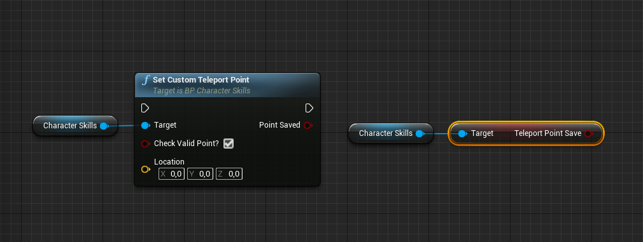
SetCustomTeleportPoint - It is possible to specify the teleportation spot location with the help of this function. CheckValidPoint? determines whether to check the possibility of teleportation in this spot: it verifies if the character's dimensions will fit in and if other objects won't be obstructions in the spot. Location is the location that needs to be saved for the teleportation. PointSaved is a parameter that determines whether the location was successfully saved for the teleportation. If it is True then nothing obstructs the teleportation of the character. TeleportPointSave determines whether there is a saved location for teleportation.

Events in the class of effects (refer to section "Class of Effects" for details).
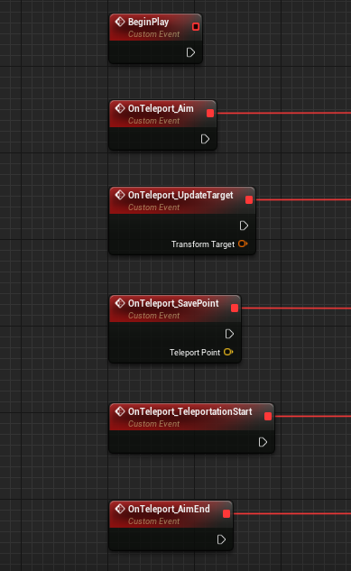
OnTeleport_Aim - is triggered when aiming.
OnTeleport_UpdateTarget - is triggered when the position is updated. TransformTarget is the position of the crosshair.
OnTeleport_SavePoint - is triggered when saving the location for the teleportation.
OnTeleport_TeleportationStart - is triggered when the teleportation starts.
OnTeleport_AimEnd - is triggered when leaving the aiming mode.

Magical skill:
The magic skill allows the character to use the left hand for various actions including the magic. By default, there are 3 firing modes: single-shot, continuous firing and firing over an area, when the whole body of the character is used. Before reading the settings for the magic, we would like to recommend you to get familiar with the section “Class of effects” to understand how the skill is implemented. There is a detailed description of the skill behavior there.
The magical skill is activated with the help of the following functions:

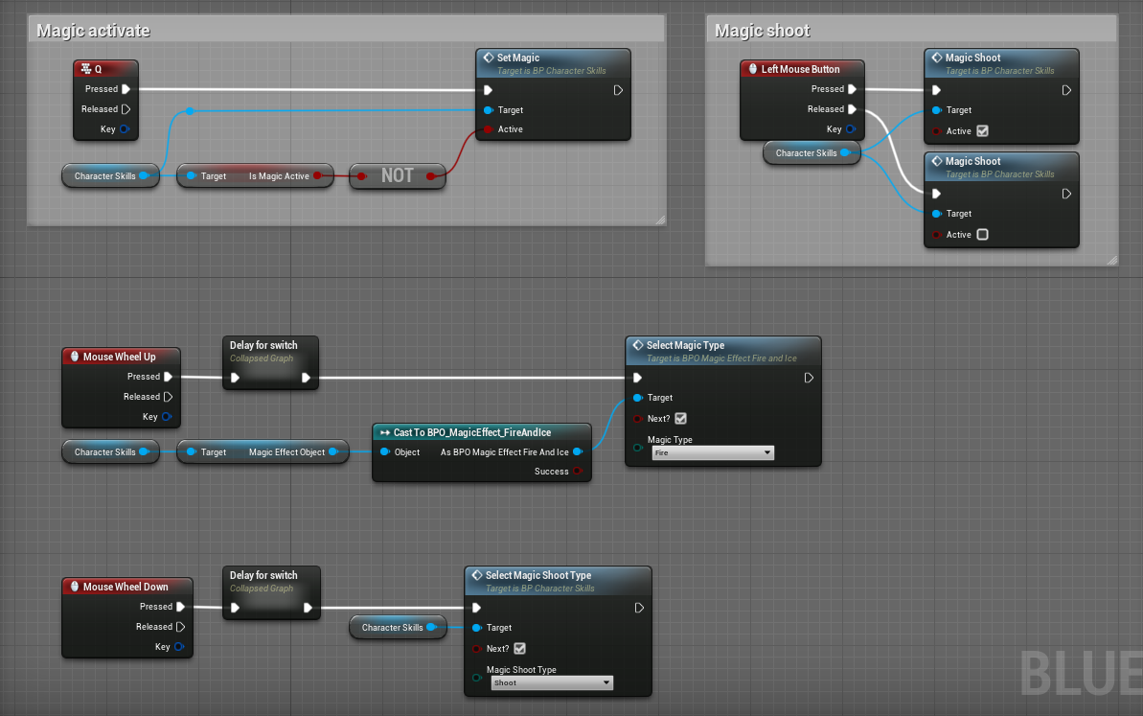

SetMagic - activates or deactivates the skill.
MagicShoot - is firing with the magic.
SelectMagicShootType - is a selection of one out of three firing modes.
SeletMagicType - selects the magic type. The function is not a function of 'Character Skills' and it is called from the class of effects where the logic of shooting with the fire, the ice, and the electricity is implemented.
Settings of the ‘Magic’ skill:
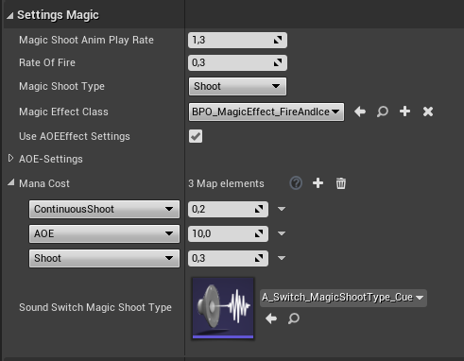

MagicShootAnimPlayRate - is the animation playback speed during firing.
RateOfFire - is the firing rate with single magical shots.
MagicShootType - is the current firing mode.
MagicEffectClass - is the class of effects for magic.
UseAOEEffectSettings -determines whether to use area-of-effect (AOE) settings from the class of effects.
AOE-Settings - are settings for the AOE attack. They are discussed in more detail in section “Settings for fire, ice, and electricity”.
ManaCost - is mana usage cost for each firing mode.
SoundSwitchMagicType - are sounds when switching the firing mode.

Additional functions and variables when using the skill:

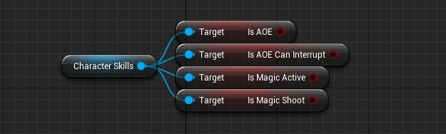

IsAOE - determines the states of the AOE attack.
IsAOECanInterrupt - determines whether it is possible to interrupt the AOE attack at the current moment.
IsMagicActive - determines whether the magic is activated at the current moment.
IsMagicShoot - determines the state of being in the shooting state.
Events in the class of effects (refer to section "Class of Effects" for details).
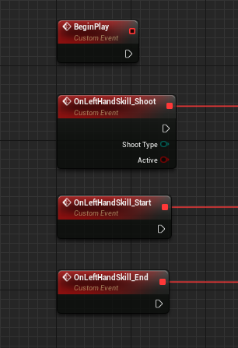
OnLeftHandSkill_Shoot - is triggered during firing when the 'magic' skill is applied. ShootType - is the current firing mode. The parameter “Active” determines whether the firing is active, for instance, for the second firing mode, when it's necessary to determine whether the continuous firing mode has been deactivated.
OnLeftHandSkill_Start - is triggered when magic is activated.
OnLeftHandSkill_End - is triggered when magic is deactivated.

Telekinesis skill:
The telekinesis skill allows the character to influence objects remotely. Apart from moving the objects from a distance, the skill also comprises various interactions with them, for instance, with enemies or with static objects such as buttons or doors. Note the parameter “Simulation Generates Hit Events” must be turned on for physical objects to interact with the telekinesis.
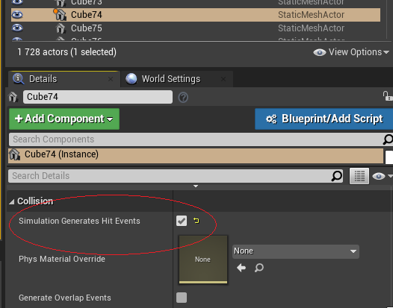
Telekinesis is activated with the help of the following functions:
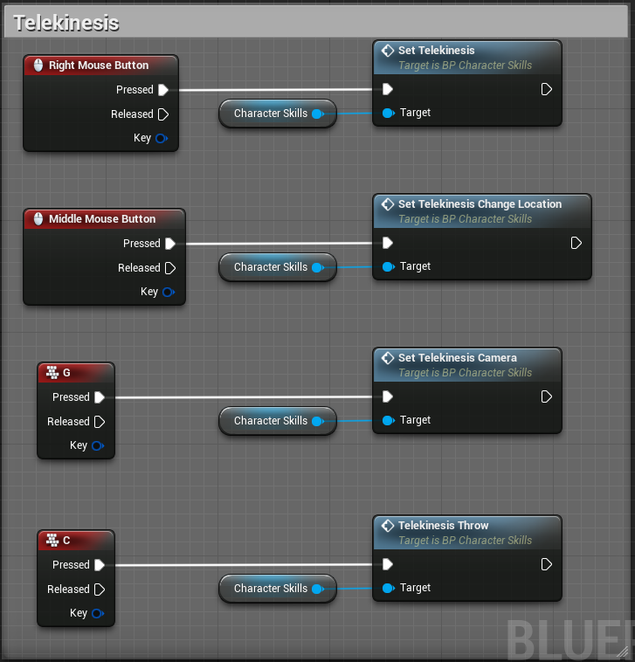
SetTelekinesis - The function activates the telekinesis and tries to grab an object in the direction of the eyesight. If the object has been grabbed already, then the character will let it go.
SetTelekinesisChangeLoaction - switches into object moving mode.
SetTelekinesisCamera - connects a camera during telekinesis. You can't use view controls when moving objects. For that, there is a camera that is focused on the object being moved.
TelekinesisThrow - The function throws an object in the direction of the eyesight.
Also, additional functions for moving objects in space are needed. The integration of the functions is discussed in section “Project Integration”

Settings of the ‘Telekinesis’ skill:
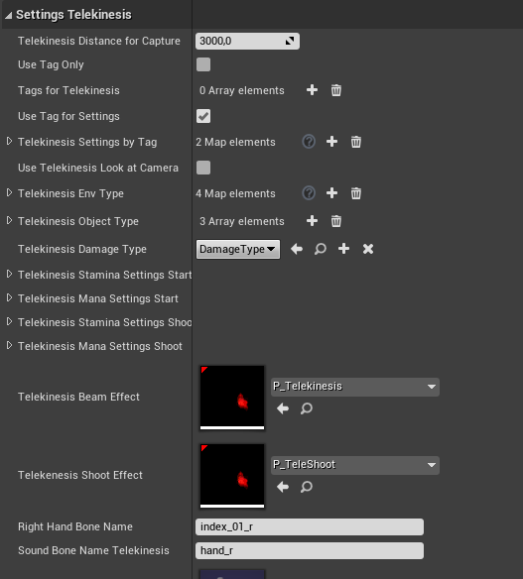
TelekinesisDistanceForCapture - is a distance at which the object grabbing is possible.
UseTagOnly - Only objects with a certain tag are susceptible to the telekinesis.
TagsForTelekinesis -is a list of tags for the parameter above.
UseTagForSettings - determines whether to use a tag for the object settings. When the parameter is disabled, the “Base” settings will always be used.
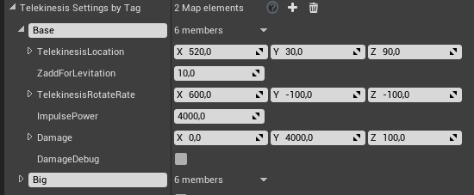
TelekinesisSettingsByTag:
TelekinesisLocation - is the location of the object relative to the character's camera.
ZAddForLevitation - is the height at which the object will levitate during the grabbing state.
TelekinesisRotationRate - is there the rotational force of the object.
ImpulsePower - is the impulse strength when throwing the object.
Damage - is the amount of damage caused by this object type that is calculated based on the speed of the object during a collision.
X - is the minimum speed.
Y - is the maximum speed.
Z - is the inflicted damage value.
For instance, if during the collision the object has a speed of 2000 units, then it inflicts 50 units of damage.
DamageDebug - displays the damage value and the object's speed on the screen. The parameter is implemented for the convenience of adjusting the collision force of the object.
UseTelekinesisLookatCamera - determines whether the camera for the telekinesis is enabled by default. The camera can be enabled with the help of the SetTelekinesisCamera function described above.
TelekinesisEnvType - are the settings of interaction types with the objects. In this structure, one specifies various interaction types with objects that are having the interface “BI_Telekinesis”. More about is discussed below.
TelekinesisObjectType - are the types of objects that are susceptible to telekinesis.
TelekinesisDamageType - is a type of damage from telekinesis.
TelekinesisStaminaSettingsStart - is stamina usage when grabbing an object.
TelekinesisManaSettingsStart - is manna usage when grabbing an object.
TelekinesisStaminaSettingsShoot - is stamina usage during the throwing of an object.
TelekinesisManaSettingsShoot - is mana usage during the throwing of an object.
TelekinesisBeamEffect - is the ray effect from the right hand to the object.
TelekinesisShootEffect - is an effect during the throw.
RightHandBoneName - is the name of the right-hand bone of the character's skeleton.
SoundBoneNameTelekinesis - is the name of the character's skeleton bone from which the sounds will be emitted.
Next come the settings of sounds in various states of the telekinesis.

Additional functions and variables when using the skill:
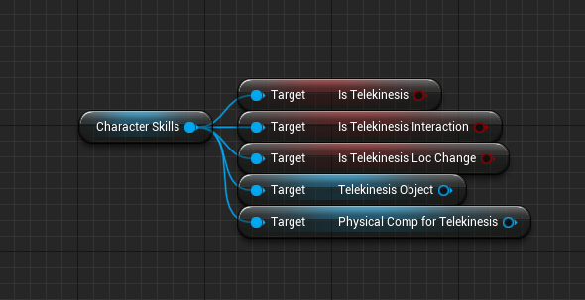
IsTelekinesis - is the state of active telekinesis skill.
IsTelekinesisInteraction - is the state of the interaction of telekinesis. (BI_Telekinesis)
IsTelekinesisLocChange - is the state of moving an object in the current moment.
TelekinesisObject - is the actor with which the skill is interacting at the moment.
PhysicalCompForTelekinesis - is a component of the specfied above actor with which the telekinesis skill is interacting in the current moment.

Interaction with objects with the help of telekinesis:
Interaction with any actors with the help of the telekinesis is done with the help of the interface “BI_Telekinesis”. The first thing is to add the interface to the key actor with whom you want to interact. The interface is attached in ClassSettings=>Interfaces. The function in the category 'Interface' becomes available for you after attaching the interface.
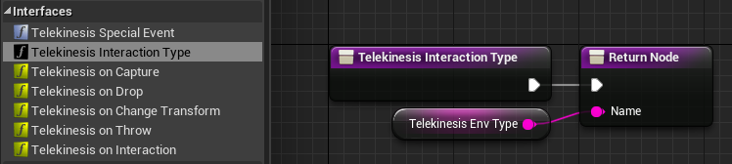
TelekinesisInteractionType - is a function that switches the interaction type of the telekinesis from grabbing the object to interacting with the object. The variable Name is responsible for the interaction type. If Name is empty then the telekinesis treats the object as a physical one and grabs it for movements. If Name has a specified interaction type in it, then the telekinesis will find the type and will call the corresponding system for the interaction. This is how the interaction system works:
1. It searches for the interaction type in map variable TelekinesisEnvType
2. Then the events get triggered at a specific time set in the interaction type.
3.A function is called inside the object with the help of the interface TelekinesisOnInteraction.
The types of interactions are specified in the variable TelekinesisEnvType in settings of the telekinesis.
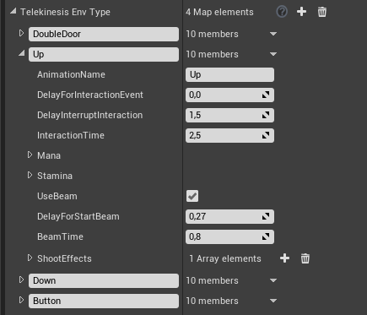
Let's consider the interaction type “Up”. By default, it is something that will be lifted with the help of the telekinesis.
AnimationName - is the name of the character's animation for this interaction. The animation itself is specified in “AnimBP_CS” in tab “Animations Right Hand Skill” and is assigned the name (map variable - TelekinesisEnvAnimations).
DelayForInteractionEvent - is the time delay after which the event will be called in the object.
DelayForInterruptInteraction -is a time-period after which it is possible to interrupt the interaction.
InteractionTime - Is the total time of the interaction duration..
Mana - is the mana usage cost during the interaction.
Stamina - is the stamina usage cost during the interaction.
UseBeam - determines whether to use the ray effect during the grabbing of an object..
DelayForStartBeam - is a time delay after which the ray is activated.
BeamTime - is a lifetime of the active ray.
ShootEffects - are effects from firing shots. A time is specified after which the effect from throwing with the telekinesis will be activated. It is possible to key in several ones.
Video tutorial. In this video, we explain the moment of interaction between an actor and a character with the help of the telekinesis. In the example, we consider the squeezing of a sphere during the telekinesis interaction then throwing it upwards. You can implement interactions with buttons, enemies, and so on using the same approach.
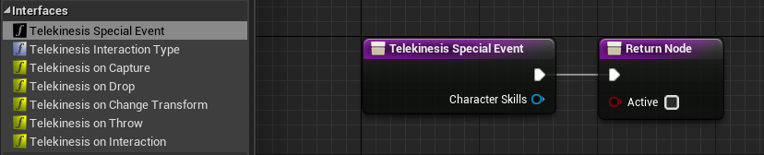
TelekinesisSpecialEvent - This function is called right before an object is grabbed. In it, you can add any extra logic. Using a piece of wall as an example, this object is not a physical one initially. After the function is called, you specify that the piece of wall is physical and, at the end of the function, you enable Active parameter. Thus, you confirm that the object got a special event called and it is possible to affect it with the telekinesis.

Mana and stamina:
Mana and stamina are additional parameters that can be used when creating skills and during their settings. Both parameters are not obligatory for use during the application of skills, but they can be useful when planning the gameplay. Mana and stamina are some skills whose values can be required for the activation of a certain skill. Mana and stamina are objects (UObject) that are created during the initialization of the component 'Character Skills'.

Mana and stamina settings:
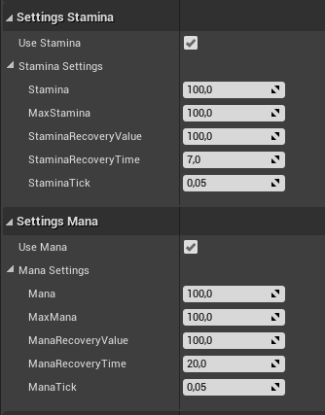

UseStamina - determines whether to use stamina. When disabled, the skills won't ask for the stamina value anymore.
Stamina - is the current amount of stamina.
MaxStamina - is the maximum amount of stamina.
StaminaRecoveryValue - is the maximum value of stamina can get restored up to.
StaminaRecoveryTime - is the restoration time of stamina.
StaminaTick - is the time-period for the update of the stamina restoration.
UseMana - determines whether to use mana. When disabled, the skill won't ask for the mana value anymore.
Mana - is the current amount of mana.
MaxMana - is the maximum amount of mana.
ManaRecoveryValue - is the maximum level of the amount of mana, the mana scale can be restored up to.
ManaRecoveryTime - is the restoration time of mana.
ManaTick - is the time-period for the update of the mana restoration.
Additional functions and variables when using mana and stamina:
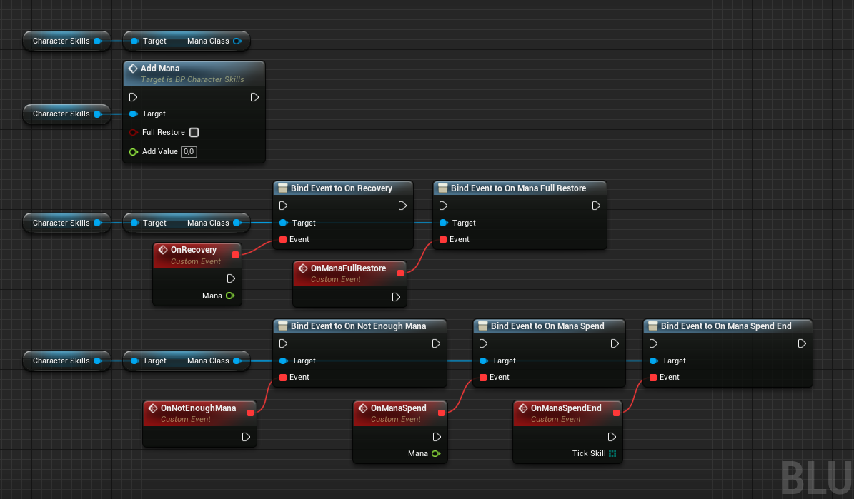
ManaClass - is a reference to the uobject of mana class..
AddMana - is a function for replenishing mana. It's optional: it is possible to restore the mana fully or only partially. The function can be useful when using various items for mana restoration.

Dispatchers:
OnRecovery - is called when restoring the mana. It might be useful when using the value for the HUD. Mana - is the current value of mana..
OnManaFullRestore - is called when mana is fully restored when using the function AddMana=>FullRestore.
OnNotEnoughMana - is called when there's insufficient mana for doing something.
OnManaSpend - is called after mana has been used. Mana - is the current value of mana.
OnManaSpendEnd - is called when continuous usage of mana is over.

Stamina works similarly in Stamina Class.

Class of Effects:
The Class of Effects is a supplementary Uobject that works together with various skills and allows one to add a logic of any complexity to the skills. By default, it contains all the necessary events for different states of a skill. When the events are called you can add code and expand the skill logic.
The interaction between the character and the class of effects is done according to the following scheme. Inside the pawn, the input is called (pressing a button). And, in its turn, it executes a skill in component 'Character Skills'. The latter outputs the key events after processing the skill (each skill got its own key events) in the class of effects. After that, in a child class, these events are overridden by adding extra logic.
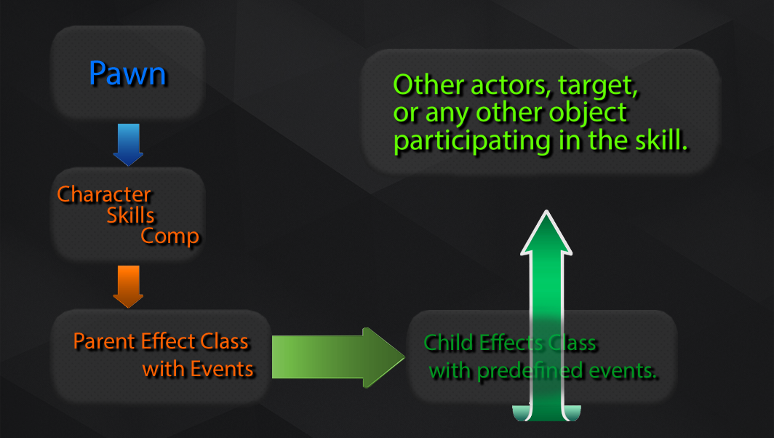

Let's use magic to illustrate how the class of effects is implemented. Magic got its class of effects containing certain events described in section 'Magical Skill'.
To add certain extra logic there, it would be better to create a child object that won't affect the parent class anyhow but it will inherit all the functions from it. By default, the parent classes are located in the following path:
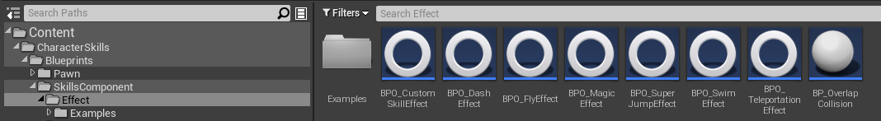
Child classes are in the folder with examples. (Examples)
To create a child class, use the Right Mouse Button and the tool “Create Child Blueprint Class”.
Let's open the class of effects for the magic that has already been created as described above. It lies in the following path:
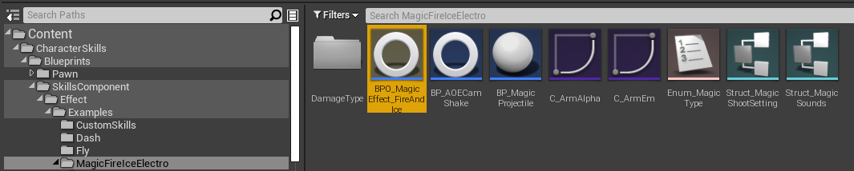

The first thing is to call the event 'BeginPlay' and add there all the necessary content: the magical hand, sounds, and effects of fire, ice, and electricity were used for the magic. So it is needed to add and attach a sound actor. After it, add a skeletal mesh for the hands and a particle. When changing the magic type, the parameters of the content will be overwritten, this sound will be changed, as well as the material and effect on the hand. The emitter type for the particles will be changed also.
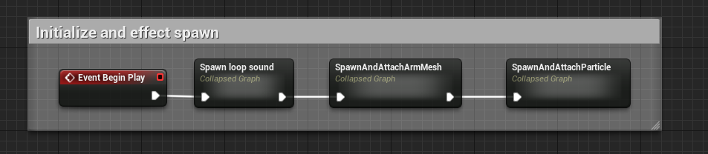
The content for the skill is ready.
Add key events OnLeftHandSkill_Start and OnLeftHandSkill_End.
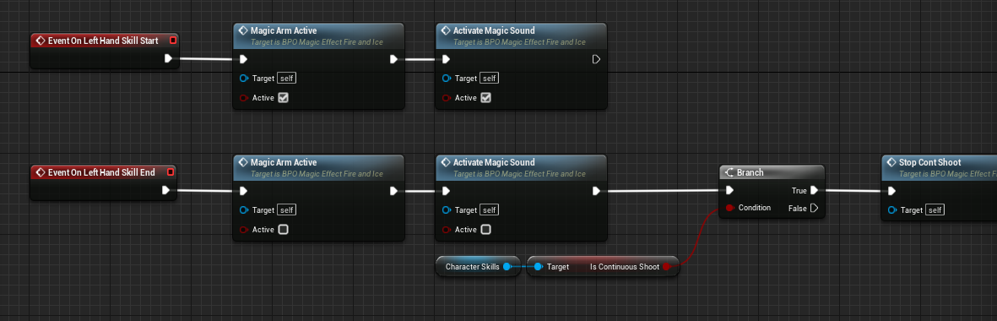
These events are responsible for the beginning of turning on and off the magical skill. Here we add logic for turning on the display of the magical hand, sounds, and effects, as well as the logic for turning them off when the skill is deactivated.
Further, we got the key event OnLeftHandSkill_Shoot that is triggered during firing. We must divide the logic into 6 parts in the event: three firing modes and three types of magic.
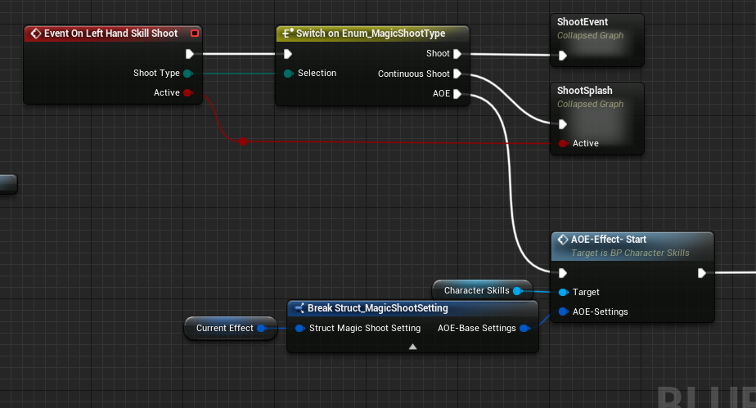
In the beginning, the selection of the firing mode is done based on the input data coming from this skill via the key event “OnLeftHandSkill_Shoot”. Next, this selection continues based on data added in the class of effects: these are three types of magic.
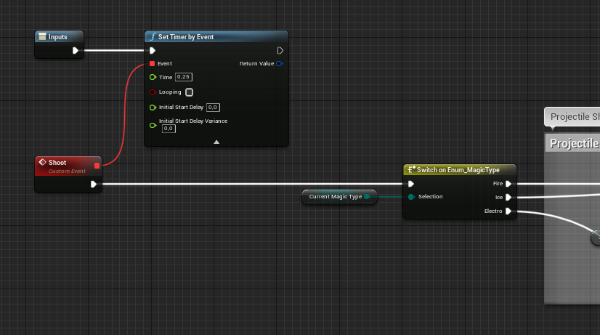
Thus, the logic is not bound anyhow to component 'Character Skills': it can be expanded as the gameplay requires.
Apart from key events of the current skill, the class of effects contains a reference to “Character Skills”. In its turn, the “Character Skills” component has a reference to the character who activates the skill. In other words, you can reference the character directly.
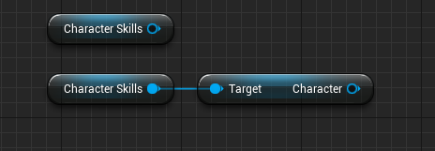
It is always possible to reference the class of effects via references in category “Variables=>EffectUobjects”.
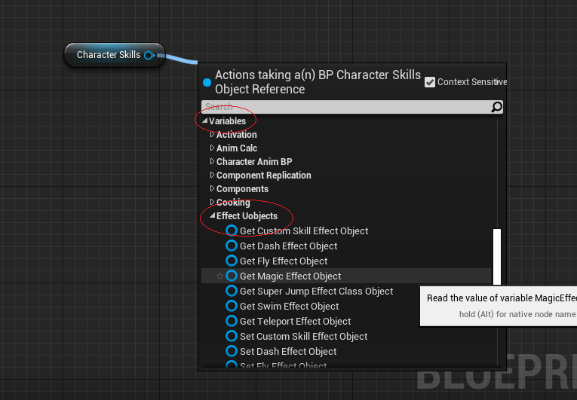
For instance, if there's a need to reference the class of effects from the pawn as it was done when switching the type of magic.
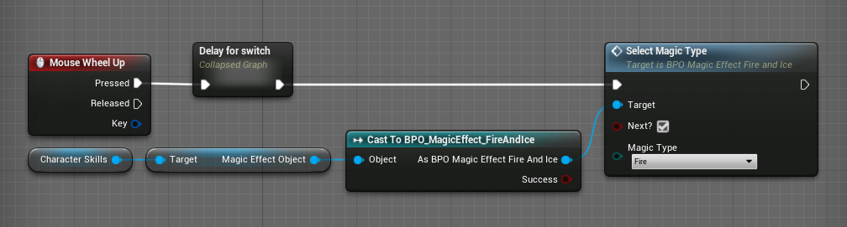

By doing so, you can always add extra logic to any skill or add additional modules.

Settings for Fire, Ice, and Electricity:
Settings for fire, ice, and electricity are inside the class of effects “BPO_MagicEffect_FireAndIce” in category “Magic Settings”.
Press ClassDefaults to see them.
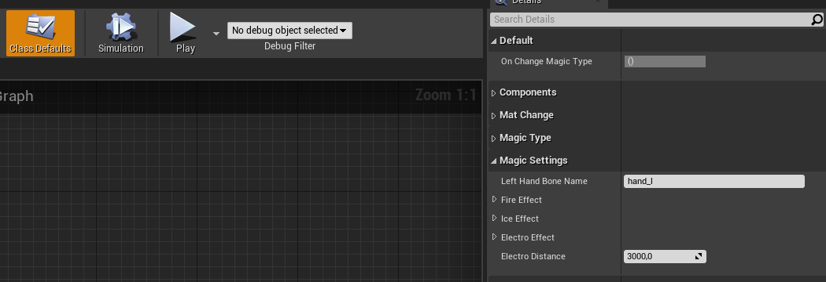
LeftHandBoneName - is the name of the character's left palm bone.
FireEffect - are settings for fire.
IceEffect - are settings for ice.
ElectroEffect - are settings for electricity.
ElectroDistance - Is the maximum distance of a single shot with electricity..

Let's discuss in more detail the settings of an element using fire as an example.
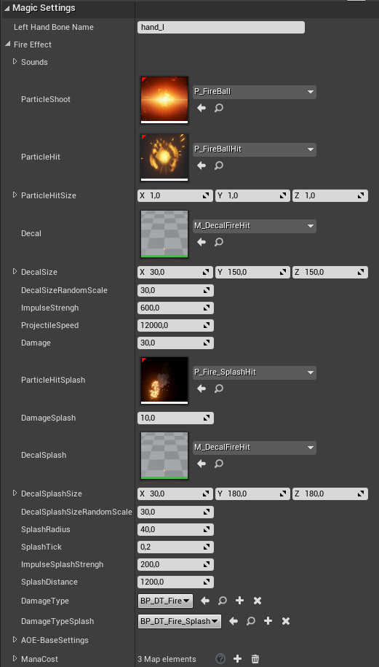
Sounds - is a list of sounds for various states of fire magic.
ParticleShoot - is a particle of a single-shot moving fire projectile.
ParticleHit - is a particle for the projectile collision.
ParticleHitSize - is the size of the particle when it hits something.
Decal - is a decal that appears when the projectile collides with something.
DecalSize - is the size of the decal.
DecalSizeRandomScale - is a random size of the decal within a given range.
ImpulseStrengh - is the impulse value for physical objects.
ProjectileSpeed - is the speed of the projectile.
Damage - is the amount of damage dealt by the projectile.
ParticleHitSplash - is a particle that appears when the fire touches an object during an AOE attack.
DamageSplash - is the amount of damage dealt during the AOE attack.
DecalSplash - is a decal that appears during the AOE attack.
DecalSplashSize - is the size of the decal.
DecalSplashSizeRandomScale - is a random size of the decal within set limits.
SplashRadius - is a radius for the AOE attack.
SplashTick - is a time-period after which the damage is applied to the area.
ImpulseSplashStrengh - is the impulse value for physical objects.
SplashDistance - is a distance for the AOE attack.
DamageType - is the damage type when firing single shots. It is the type of damage that causes the enemies to react to the elements.
DamageTypeSplash - is the damage type for the AOE attack.
AOE-BaseSettings - are the settings for the AOE attack, i.e. a powerful area-of-effect attack around the character.
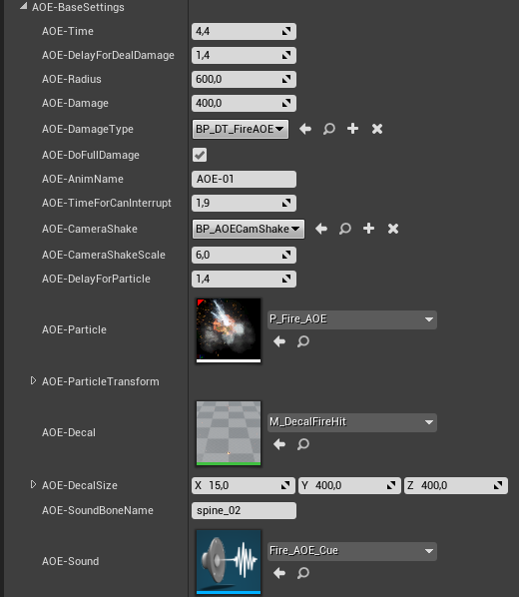
AOE-Time - is the duration of the AOE attack.
AOE-DelayForDealDamage - is a time-delay after which the damage will be dealt.
AOE-Radius - is a radius of the attack..
AOE-Damage - is the amount of damage.
AOE-DamageType - is the type of damage.
AOE-DoFullDamage - When enabled, the full damage value will be dealt. When disabled, the amount of damage will decrease based on the distance to the character.
AOE-AnimName - is a name for animation of the AOE attack. The animation itself is specified in “AnimBP_CS” in tab “Animations AOE” and is assigned the name (map variable).
AOE-TimeForCanInterrupt - is a time delay after which it is possible to interrupt the AOE attack.
AOE-CameraShake - is a class for the shaking of the camera.
AOEDelayForParticle - is a time-delay for the particle playback.
AOE-Particle - is an AOE effect.
AOE-ParticleTransform - is the transform of the particle relative to the character..
AOE-Decal - is a decal.
AOE-DecalSize - is the size of the decal.
AOE-SoundBoneName - is a name of a bone to which the AOE sound will be attached to.
AOE-Sound - is a sound for the AOE.
ManaCost - is mana cost for each firing regime.
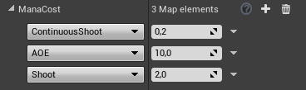

Custom Skill or the constructor of skills:
The tool “Custom Skill” comprises a large number of functions that can be combined into unified logic creating unique skills.
“Custom Skill” is activated with the help of the function SetCustomSkill:
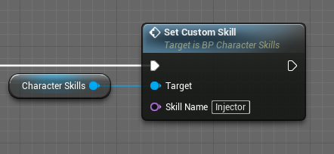
SkillName - is a name specified in the constructor.
Settings of “Custom Skill”:
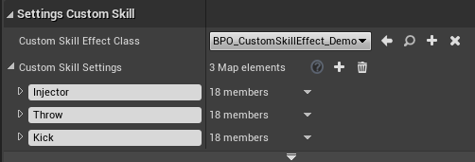

CustomSkillEffectClass - is a class of effects for unique skills. By default, it contains code for spawning a syringe and its animation when applying the skill.
CustomSkillSettings - are settings of the skill. Each skill got a name assigned to it. It is the name that is used to call the skill.

Skill settings:
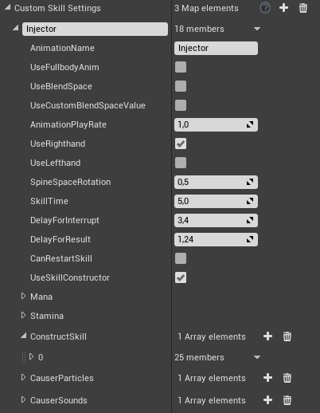

AnimationName - is a name for the skill animation. The animation itself is specified in “AnimBP_CS” in tab “Animations Custom Skills” and is assigned the name (map variable). If you use BlendSpace animation, then add it in CustomSkillBlendSpace. Otherwise, add it in CustomSkillAnims.
UseFullbodyAnim - determines whether the whole body will be used for the skill. For instance, during the close-quarter combat and such.
UseBlendSpace - determines whether to use the Blendspace. By default, the Blendspace has two parameters and they are assigned Yaw and Pitch values. But you may change these parameters with whatever you want during the working of the skill with the help of the parameter below.
UseCustomBlendSpaceValue - When enabled, you need to specify your own data for the Blendspace. When disabled, they will remain Yaw and Pitch values.
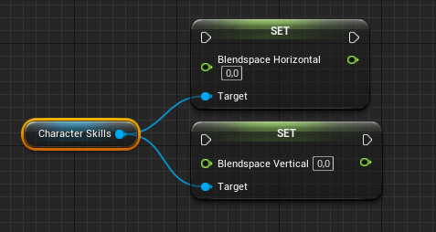

AnimationPlayRate - is the animation playback speed.
UseRighthand determines whether to use the right side of the body. The character will use the right side of the body for the animation of the skill.
UseLefthand determines whether to use the left side of the body. The character will use the left side of the body during the animation of the skill. When this parameter and the previous one are enabled, the character will use the whole upper body when moving.
SpineSpaceRotation is the strength of the animation influence on the character's back.
SkillTime is the duration of the skill..
DelayForInterrupt is a time-period after which it is possible to interrupt the skill.
DelayForResult is a time delay after which the result event “OnCustomSkill_Result” will be called in the class of effects.
CanRestartSkill is an option to restart the skill without waiting for its completion or interruption.
UseSkillConstructor determines whether to use additional functions from the constructor.
Mana is the cost of mane.
Stamina is the cost of stamina.

Now let's move on to the settings of the constructor. It is possible to call the constructor from one skill as many times as necessary. For example, when creating melee combat, the first call of the constructor can be made to turn the character so he faces the target. And the second call can be used to deal damage or, for instance, to apply the skill on self first and then to an area.
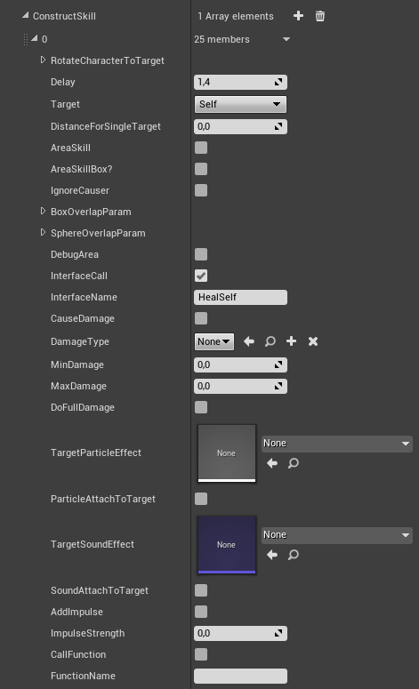

RotateCharacterToTarget allows one to turn the character so he faces a specific target.

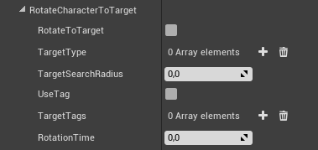
RotateToTarget determines whether to enable the function for turning the character towards the target.
TargetType is a type of the target. For instance, only pawns and such.
TargetSearchRadius is a radius relative to the character for searching for the targets.
UseTag determines whether to use a certain tag.
TargetTags determines how the tag will highlight the target for the character.
RotationTime is a time needed to turn towards the target.
Delay is a time delay between subsequent calls of the constrictor of skills.
Target determines to whom or what the skill will be applied.
Self means self, i.e. it will be applied to the character who used the skill.
LookAtTarget In the direction of the view. It will be applied to a target that is within the crosshair.
Area - over an area.
DistanceForSingleTarget is the targeting range when the target is of “LookAtTarget” type.
ObjectTypesForSingleTarget are types of objects that can be targeted by the target of “LookAtTarget” type.
AreaSkill determines whether an area will be used when choosing a target of “LookAtTarget” type.
AreaSkillBox? When enabled, a cube will be used to determine the area where the targets can be. When disabled, a sphere is used instead.
IgnoreCauser determines whether to ignore the character who has activated the skill.
BoxOverlapParam are the parameters of the cube to set up the area.

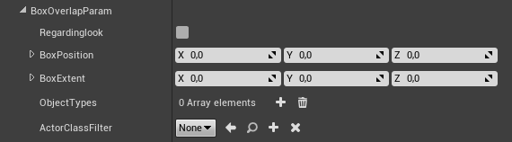

Regardinglook When enabled, the area will be located relatively to the eyesight (relative to the camera).
BoxPosition is the relative position of the cube.
BoxExtent is the dimension of the cube.
ObjectsTypes are the applicable object types for the skill.
ActorClassFilter Only certain classes of objects will be taken into account.

SphereOverlapParam are the parameters of the sphere to set up the area.

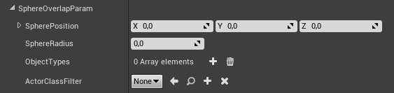

SpherePosition - is the relative position of the sphere.
SphereRadius - is a radius of the sphere.
ObjectsTypes - are types of objects that will be affected by the skill.
ActorClassFilter - Only certain classes of actors will be taken into account.
DebugArea is a function for the debugging: it draws the contours of the area.
InterfaceCall - calls target's interface. It is necessary to attach the interface “BI_CharacterSkills” to an actor to be able to call him.
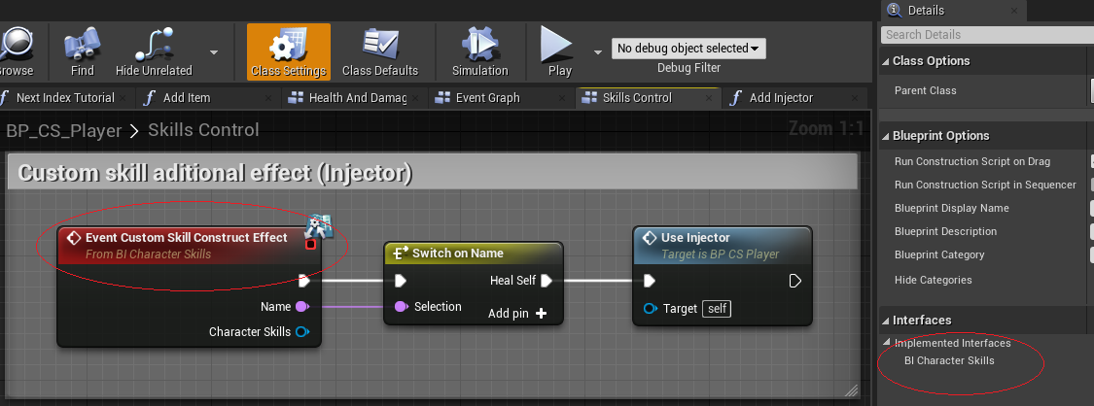
For instance, when using a syringe, the character's function is called that decreases the number of available syringes by 1 and restores the character's health.
InterfaceName - is a name in the interface function “CustomSkillConstructEffect” that is transferred via the interface to determine what you need to activate.
CauseDamage determines whether the skill deals damage.
DamageType is a type of damage.
MinDamage is the minimum damage value from the point it was called to the target.
MaxDamage is the maximum damage value from the point it was called to the target.
DoFullDamage determines whether to deal the maximum damage. In this case, only the value of MaxDamage will be used.
TargetParticleEffect is an effect that is played by the target.
ParticleAttachToTarget determines whether the effect should be attached to the target, for instance, the fire.
TargetSoundEffect is a sound that is played by the target.
SoundAttachToTarget determines whether this sound will be attached to the target.
AddImpulse is the impulse for physical objects.
ImpulseStrength is the impulse value.
CallFunction is an additional call of a function in the class of effects. There can be a situation that there's not enough data from the constructor to implement the envisioned skill. Then, with the help of the parameter, you can call any other additional function.
FunctionName is the name of the function in the class of effects.
CauserParticles adds effects to the character. It is possible to add several ones separated by a delay.
CauserSounds add sounds to the character. It is possible to add several ones separated by a delay.
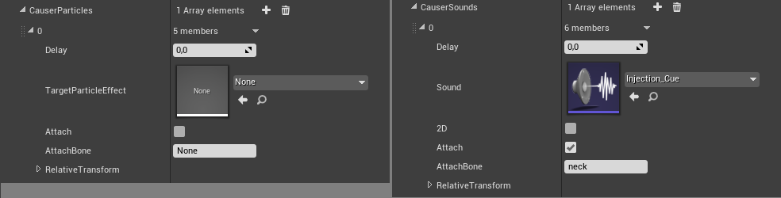
Additional functions and variables when using the constructor:

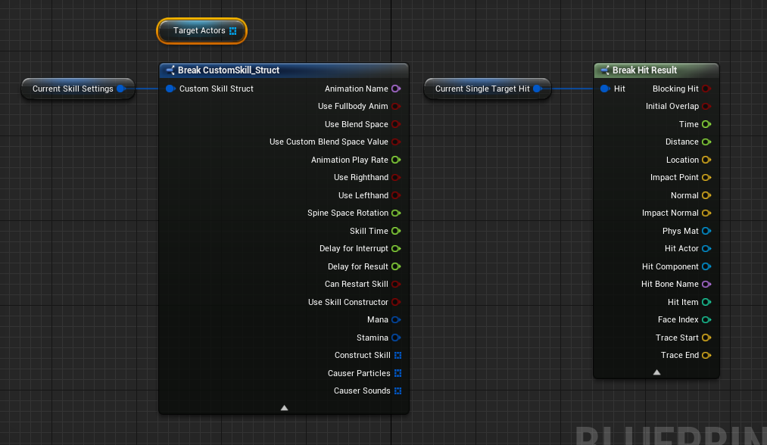

TargetActors is an array of targets that are filled with functions related to targeting an area.
CurrentSkillSettings are the settings of the current skills.
CurrentSingleTargetHit is the “Hit” structure that is returned when a target is of “LookAtTarget” type.

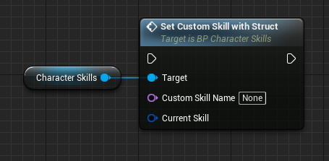

SetCustomSkillWithStruct allows one to activate a skill outside the database that is stored in component 'Character Skills'. It can be useful if you have another component dedicated to a certain type of skills. For instance, the close-quarter combat and such.

Events in the class of effects (refer to section "Class of Effects" for details)
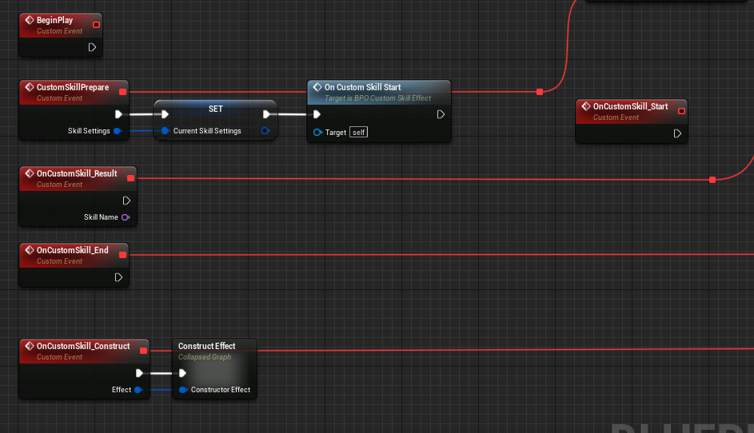
OnCustomSkill_Start is triggered when the skill is activated.
OnCustomSkill_Result is called after a delay specified in settings. SkillName is the name of a skill that caused the result..
OnCustomSkill_End is called when the skill activity is over.
OnCustomSkill_Construct is called when the constructor of skills starts.

Accordingly, with the help of the constructor by providing additional functions, it is possible to craft complex skills that can affect multiple targets including visual effects.

Turning the skills on and off:
All the skills have an option to be disabled for their selective usage. By default, in the example, we use the gradual acquisition of skills in terms of gathering strength while completing the level. A skill can be turned on or turned off in tab “Settings Available Skills”.

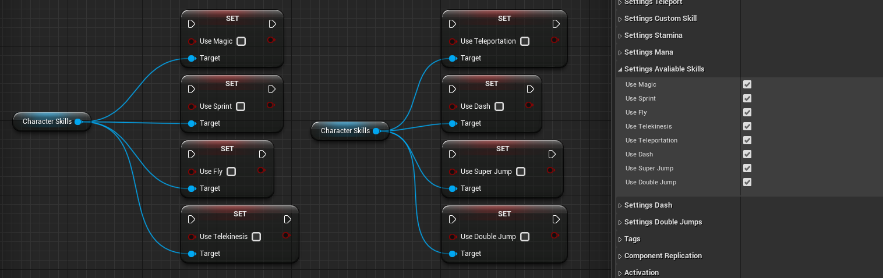

Additional information:
There are two types of enemies included in the project: a monster and a turret. The monster can fight in the close-quarter combat and at range. The turret is fighting at range and can move in the air. Both classes have been written in such a way that they can be added to any other project and they will work without requiring extra modules.

The enemies react to elements by determining the type of damage when receiving the damage. A pawn got several health components added. Each one is responsible for the resistance against a corresponding elemental damage type. It works according to the following scheme using electricity as an example:
1. An enemy receives damage.
2. It verifies the damage type: whether it is related to the electrical damage.
3. A damage is dealt to the ‘Health’ components responsible for the resistivity against electricity. If the component is depleted (Death event is called) then the character is stunned and he can't attack. You can see how it's done in more detail in the pawn's code.

Dispatcher “BackToBaseMovement”is called when the character returns into the basic movement outside 'CharacterSkills'. During the call, the basic speed of the character is modified, as well as his turning speed and the type of movement. If you have a complicated character that changes the parameters of movement often, then it makes sense to attach the logic to this dispatcher that is responsible for the current parameters of the movement of your character.

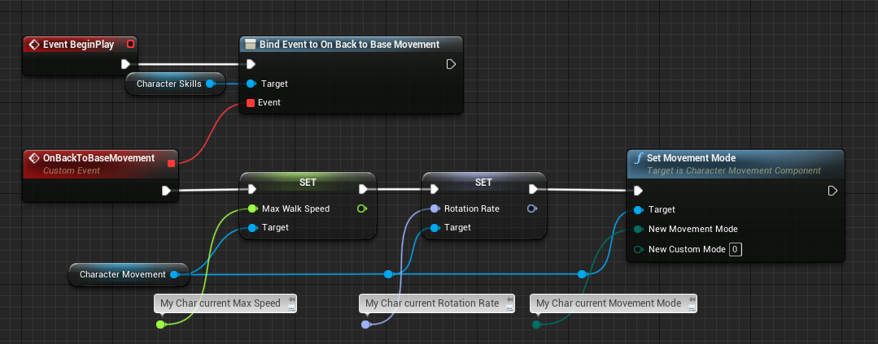

The component 'Character Skills' will display parameters that have been received during the industrialization (BeginPlay) if you don't specify your own parameters when calling the dispatcher.

The function “Deactivate All Skills” deactivates all current skills. The function can be useful when transitioning into a cutscene or during various other states of the character.

